NAME: K.KAMES

TYPE CASTING:

TYPE CASTING IS A WAY OF CONVERTING

DATA FROM ONE DATA TYPE TO ANOTHER DATA TYPE.

THERE ARE TWO TYPE OF TYPE CASTING IN JAVA

IMPLICIT TYPE CONVERSION

EXPLICIT TYPE CONVERSION

BYTE TO BYTE:

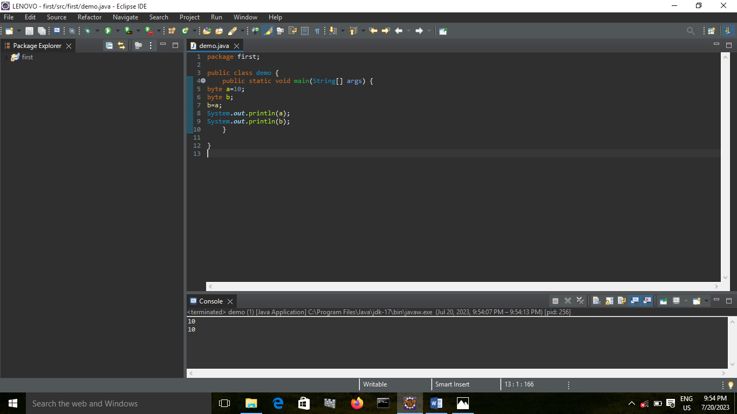

BYTE TO SHORT:

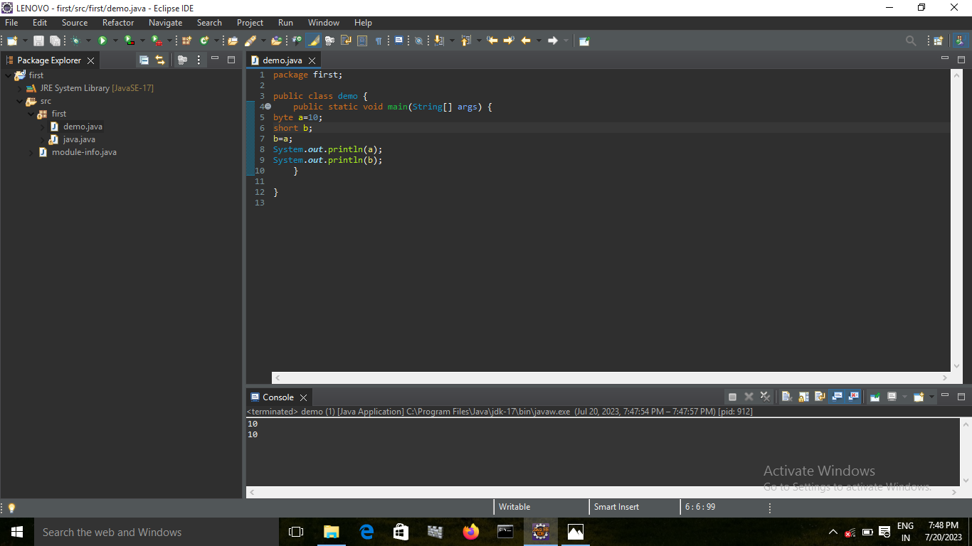

BYTE TO INTEGER:

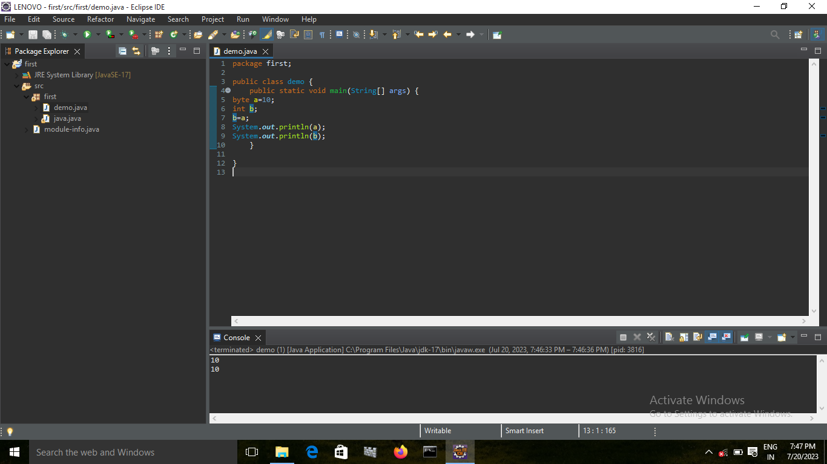

BYTE TO LONG:

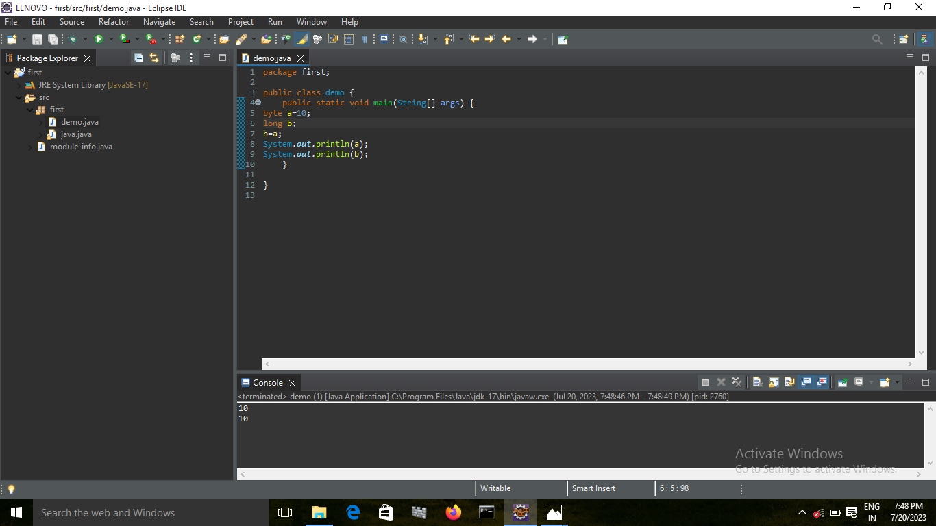

BYTE TO FLOAT:

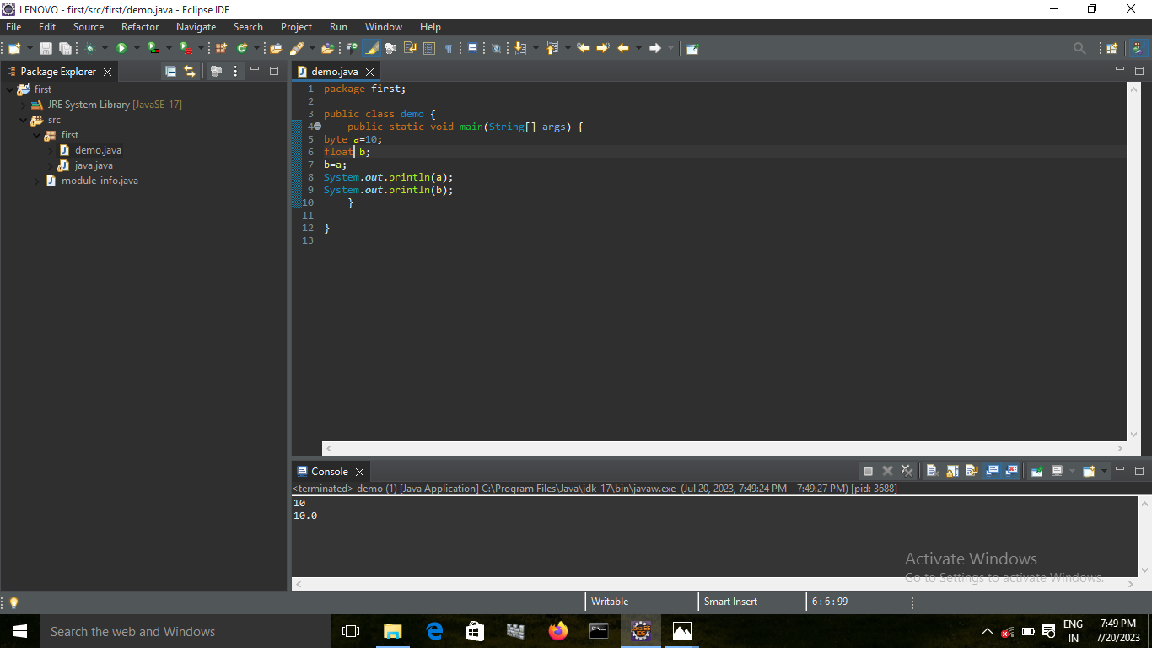

BYTE TO DOUBLE:

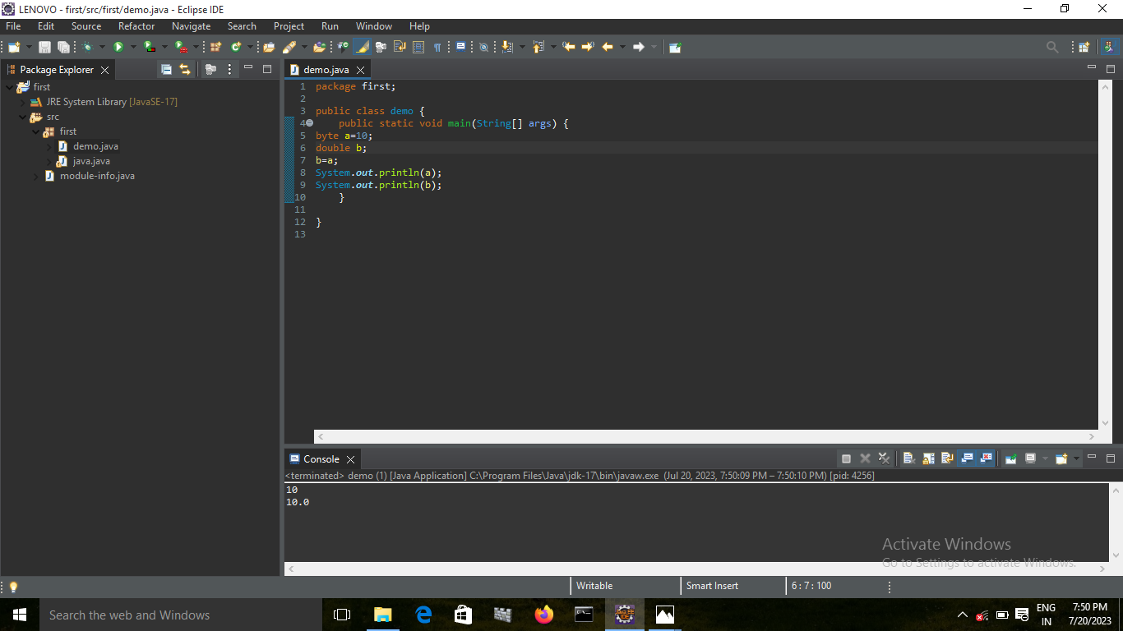

BYTE TO CHAR:

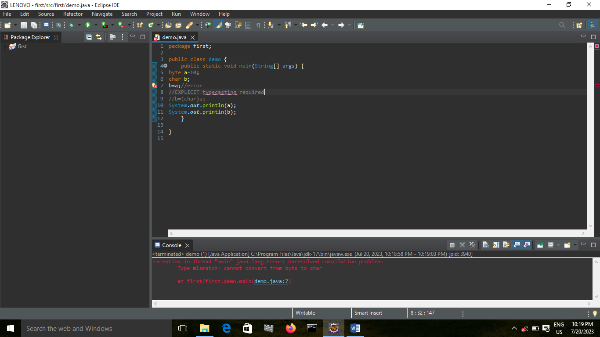

ERROR BECAUSE BYTE TO CHAR EXPLICIT TYPECASTING SHOULD BE DONE

BYTE TO BOOLEAN:

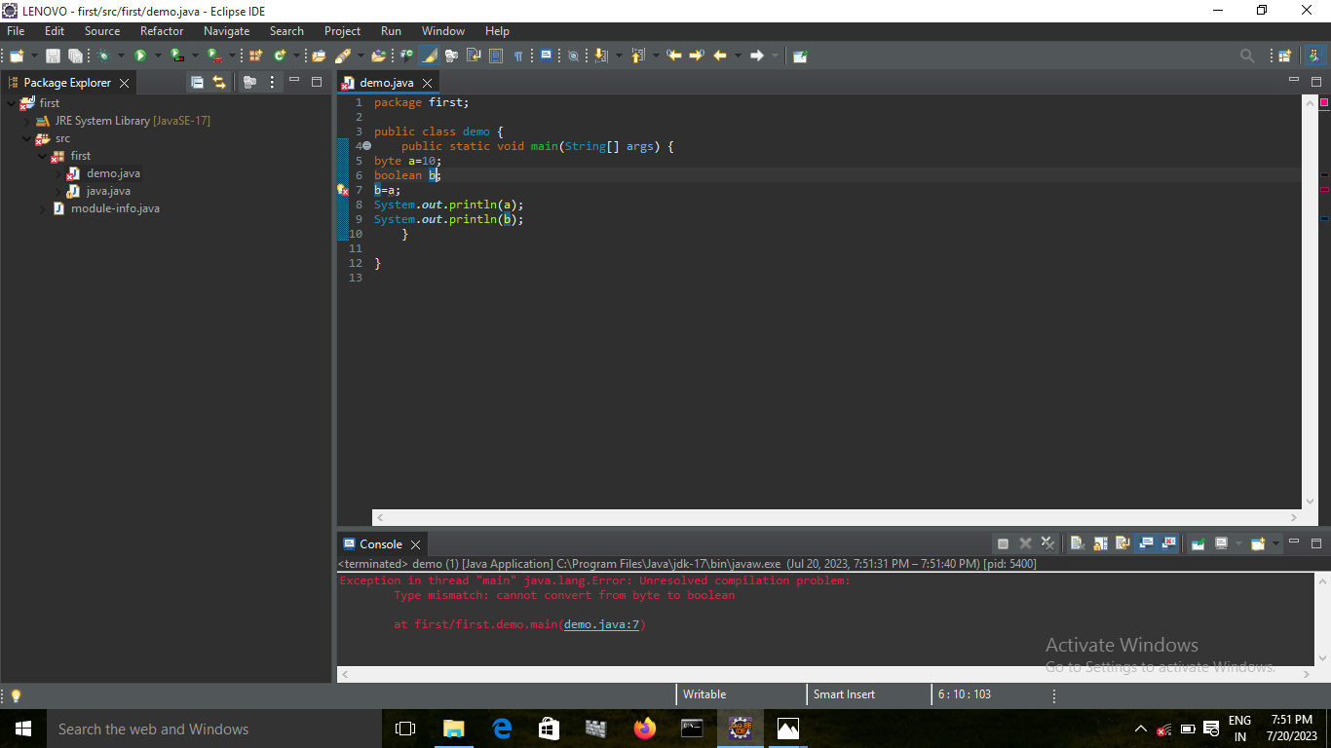

CONCLUSION: NOT POSSIBLE

SHORT TO BYTE:

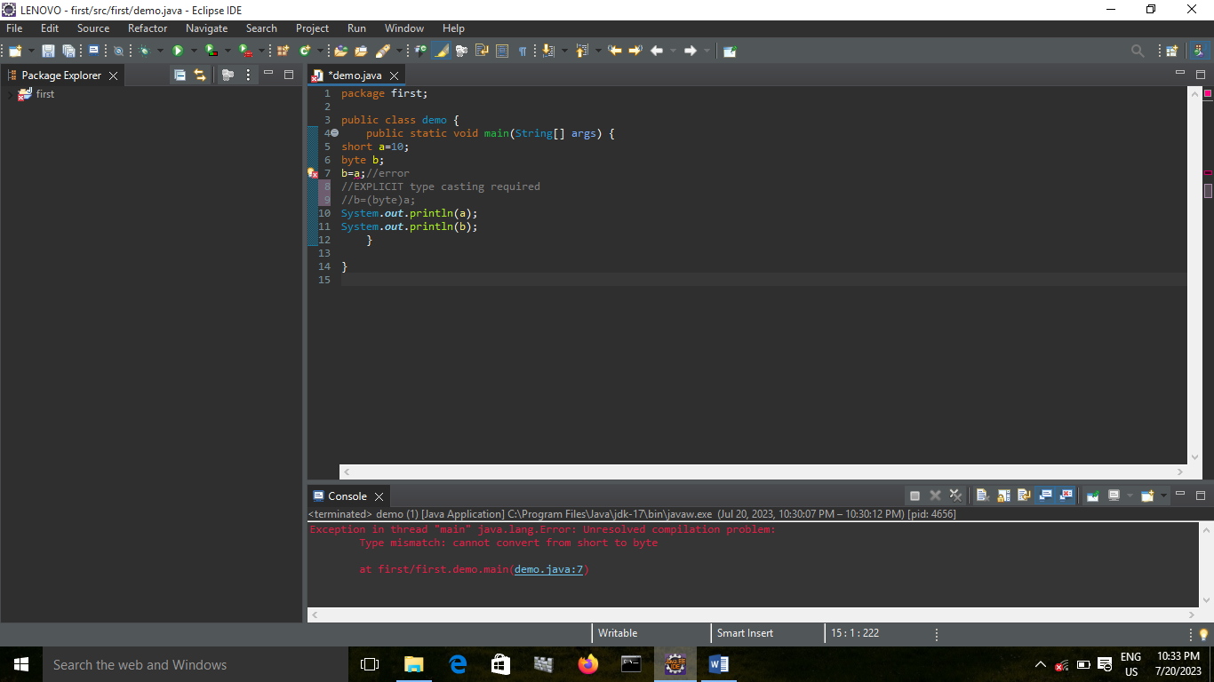

ERROR BECAUSE SHORT TO BYTE EXPLICIT TYPECASTING SHOULD BE DONE

SHORT TO SHORT:

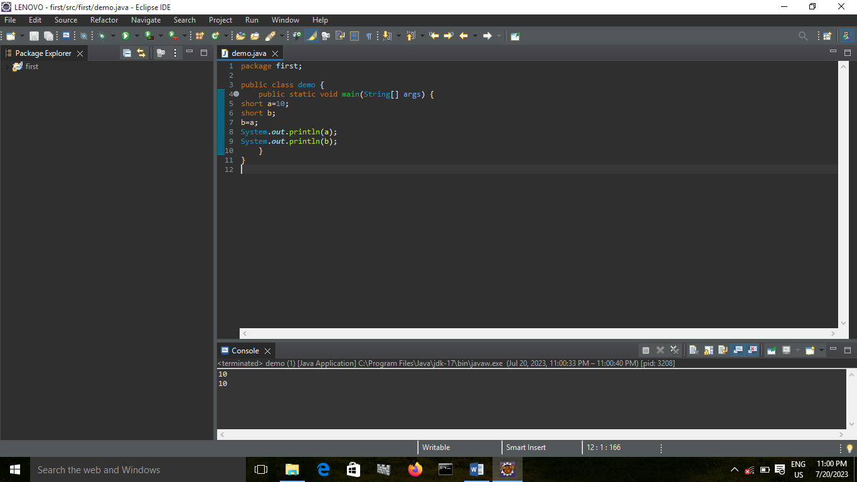

SHORT TO INTEGER:

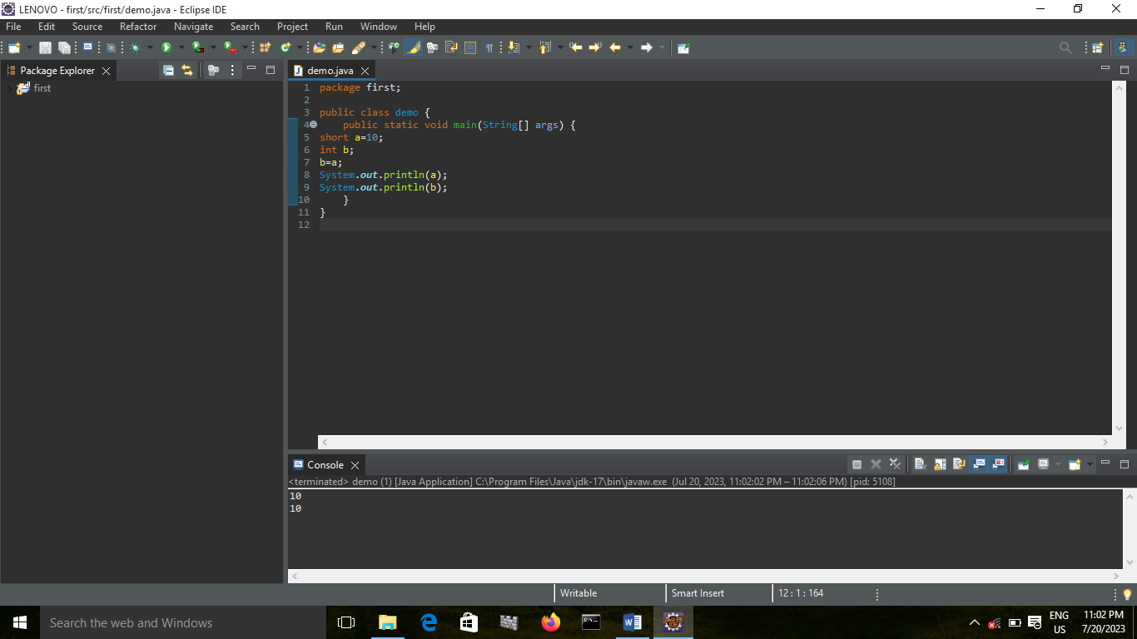

SHORT TO LONG:

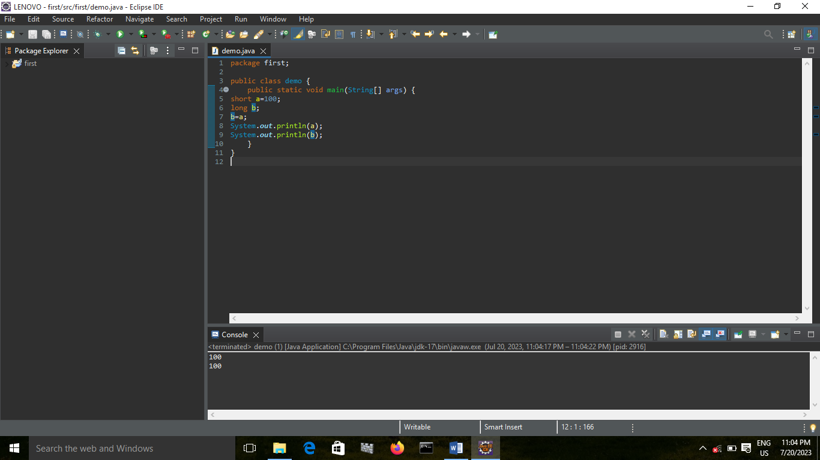

SHORT TO FLOAT:

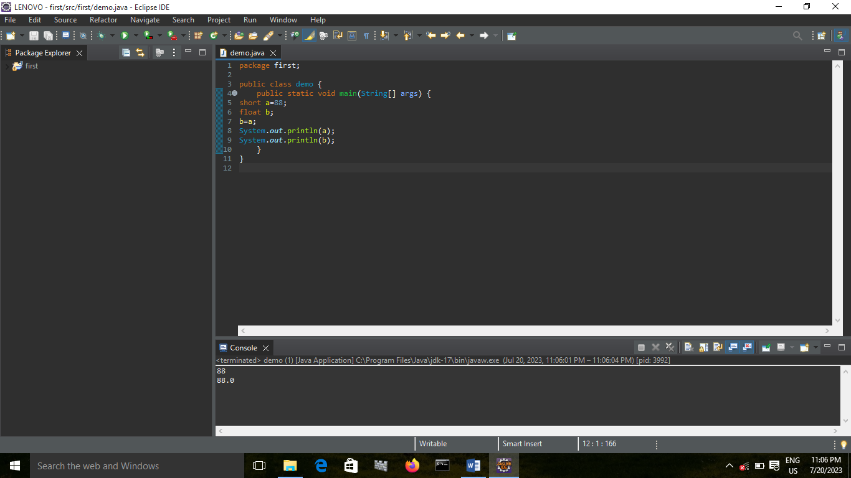

SHORT TO DOUBLE:

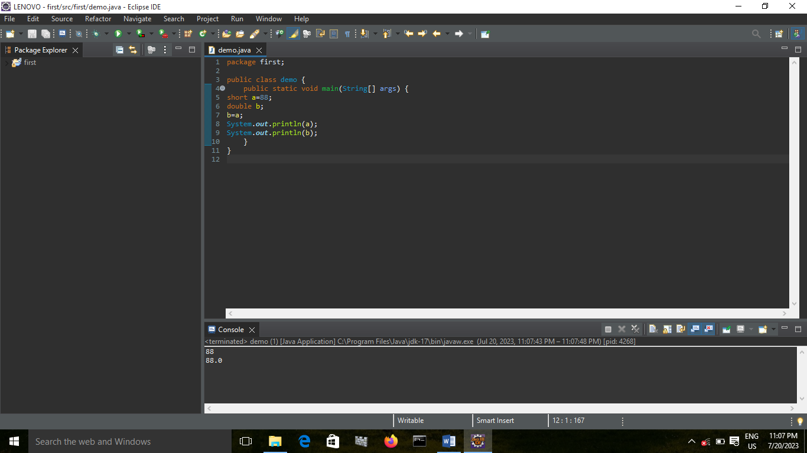

SHORT TO CHAR:

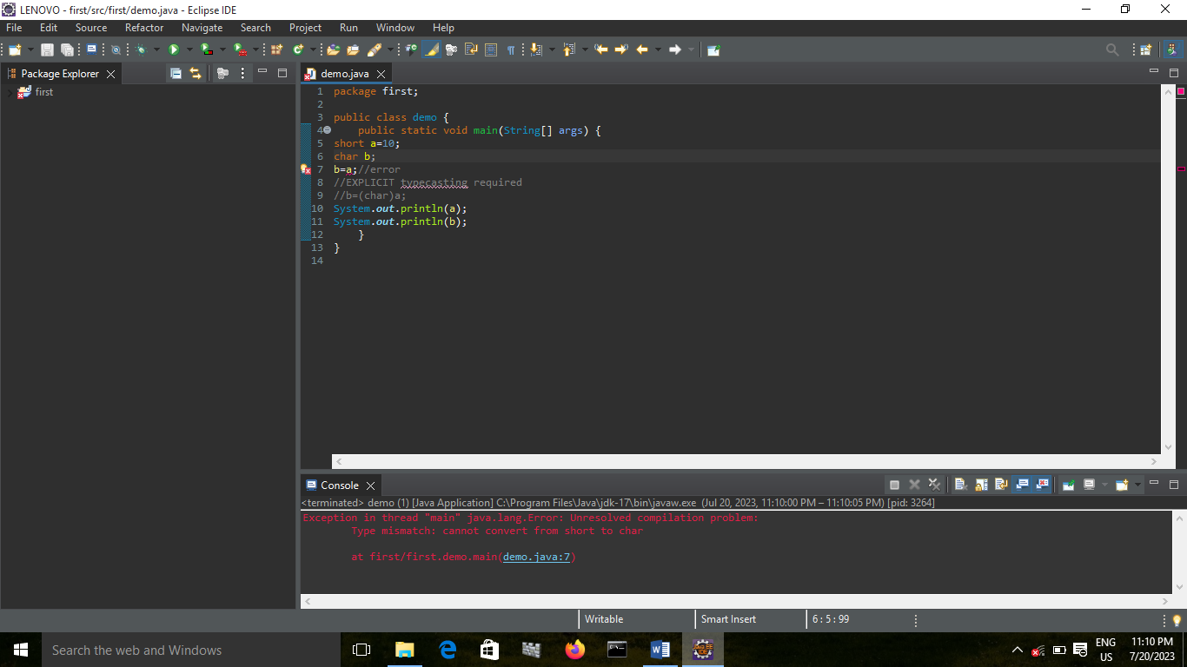

ERROR BECAUSE SHORT TO CHAR EXPLICIT TYPECASTING SHOULD BE DONE

SHORT TO BOOLEAN:

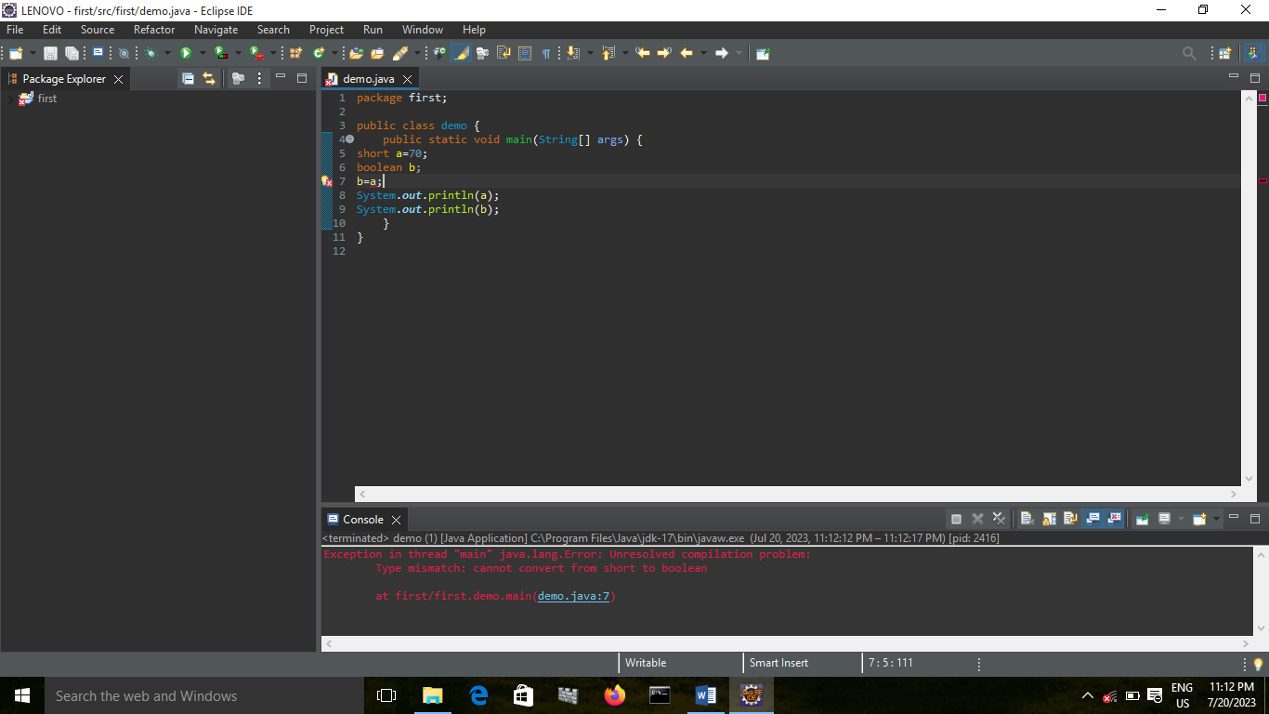

CONCLUSION: NOT POSSIBLE

INT TO BYTE:

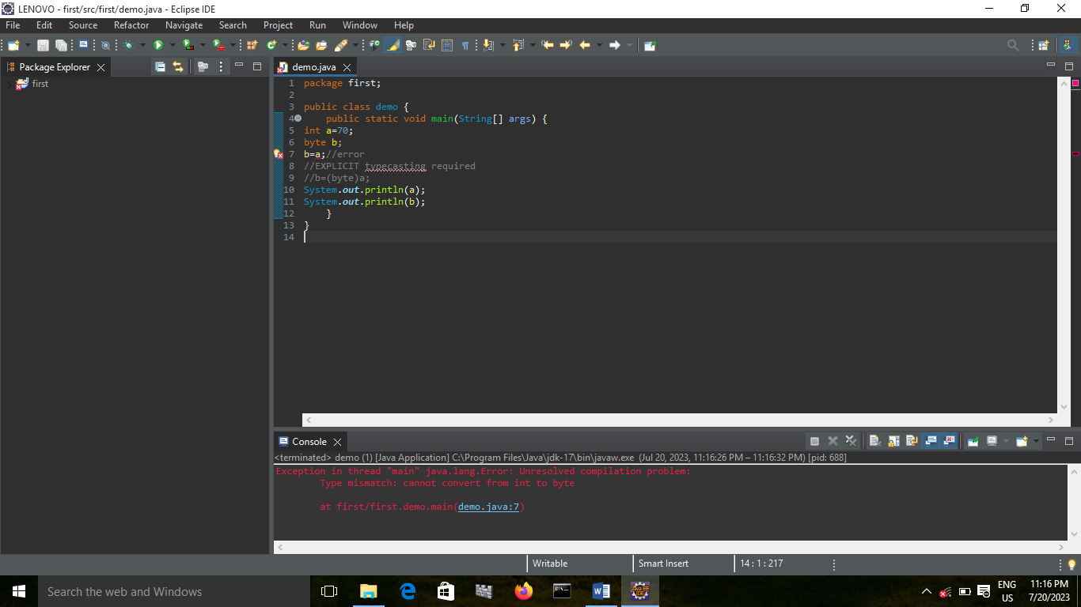

ERROR BECAUSE INT TO BYTE EXPLICIT TYPECASTING SHOULD BE DONE

INT TO SHORT:

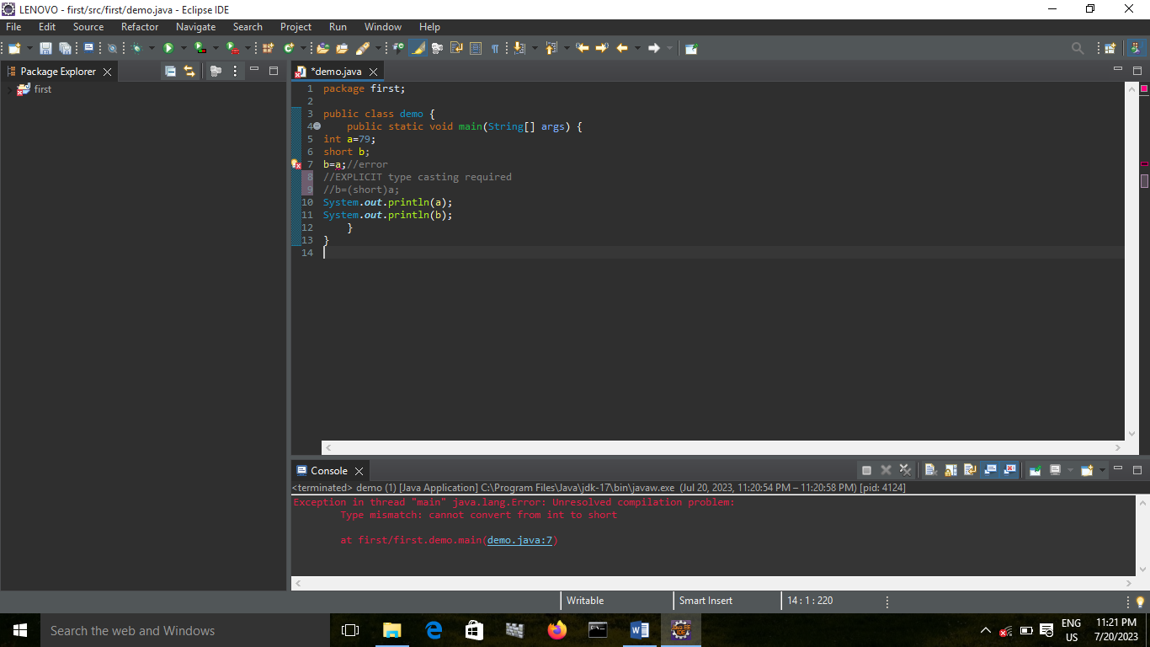

ERROR BECAUSE INT TO SHORT EXPLICIT TYPECASTING SHOULD BE DONE

INT TO INT:

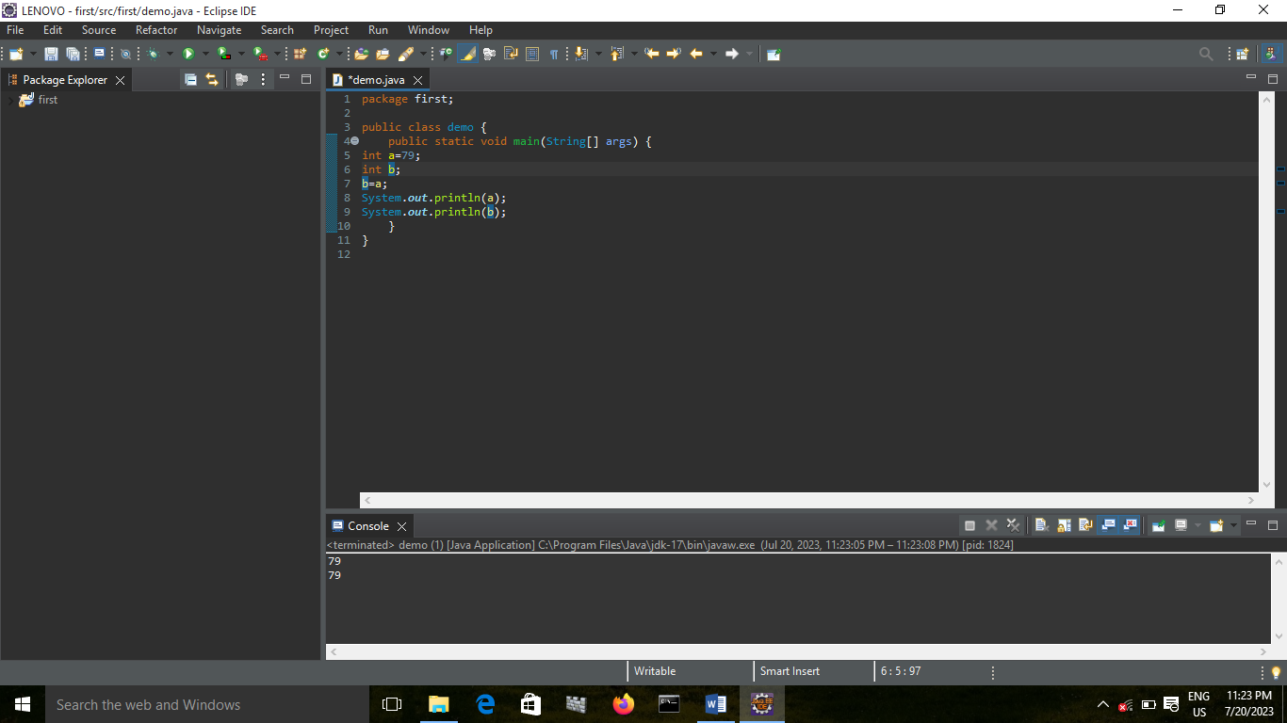

INT TO LONG:

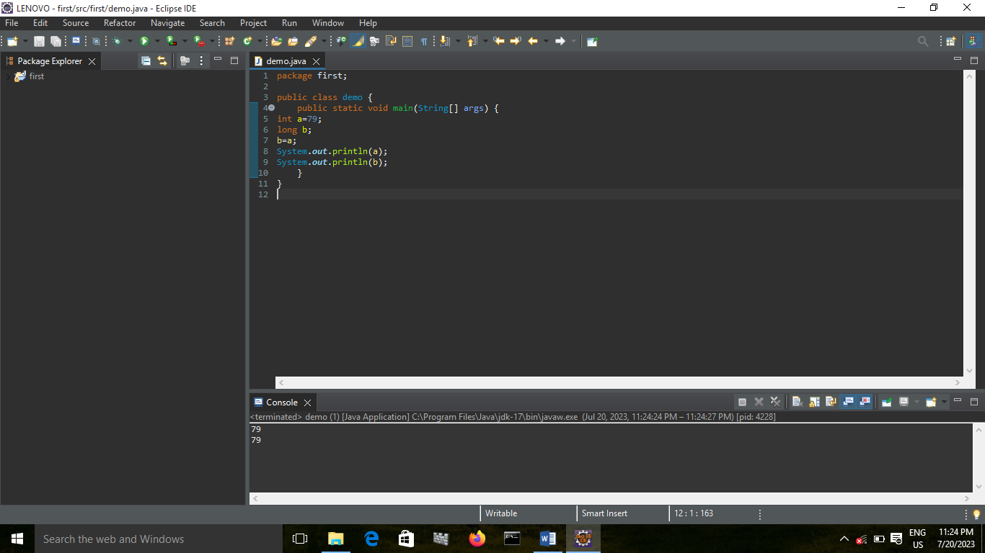

INT TO FLOAT:

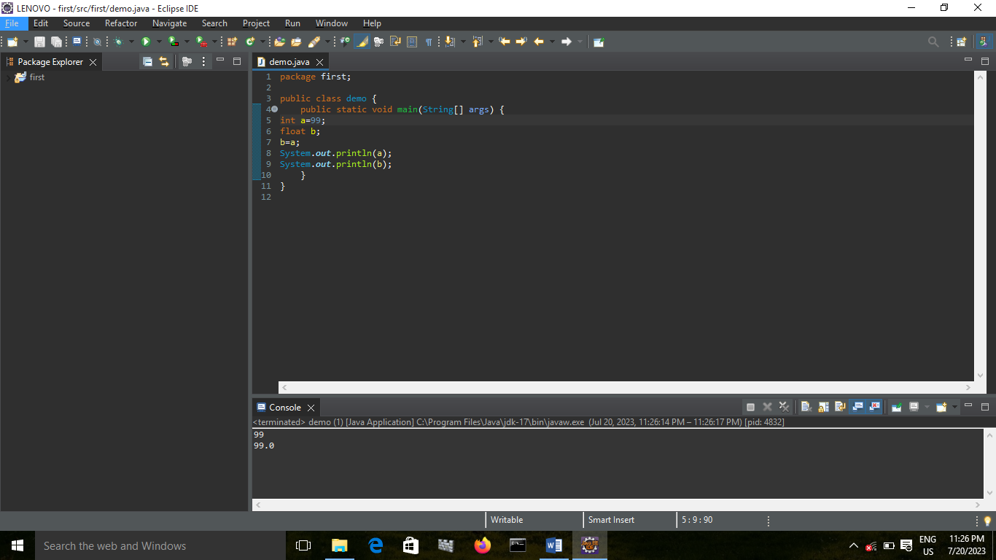

INT TO DOUBLE:

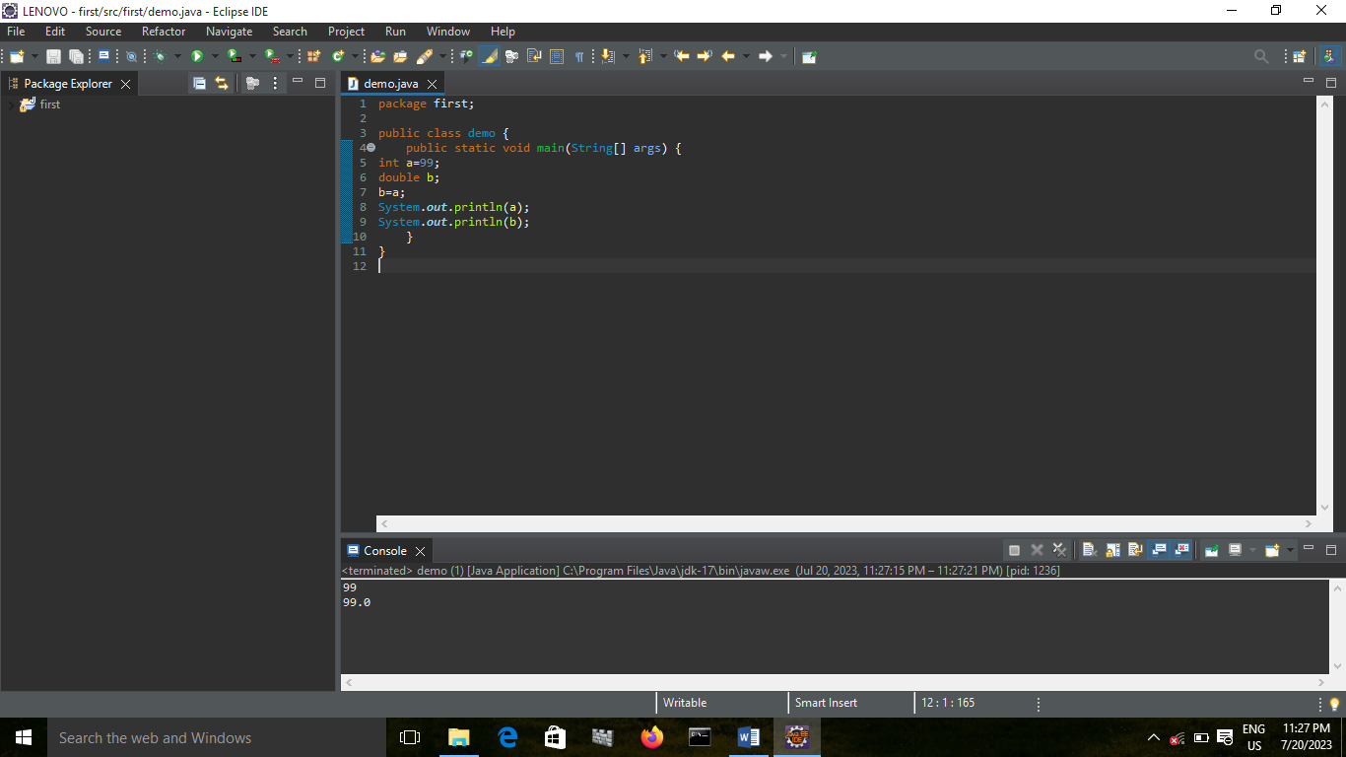

INT TO CHAR:

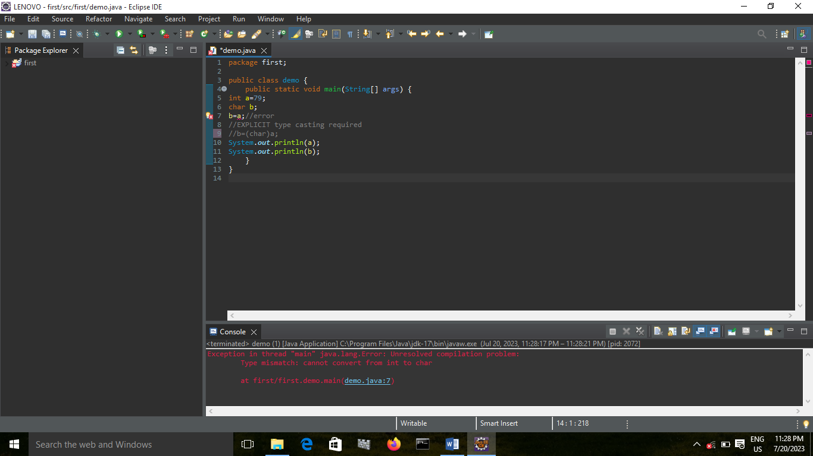

ERROR BECAUSE INT TO CHAR EXPLICIT TYPECASTING SHOULD BE DONE

INT TO BOOLEAN:

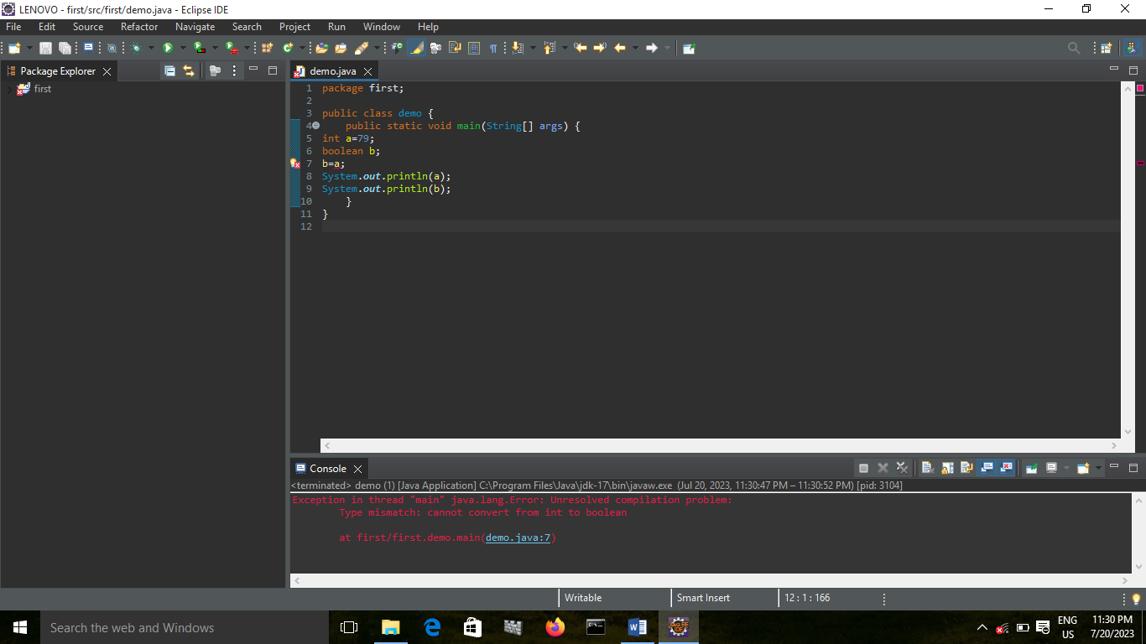

CONCLUSION: NOT POSSIBLE

LONG TO BYTE:

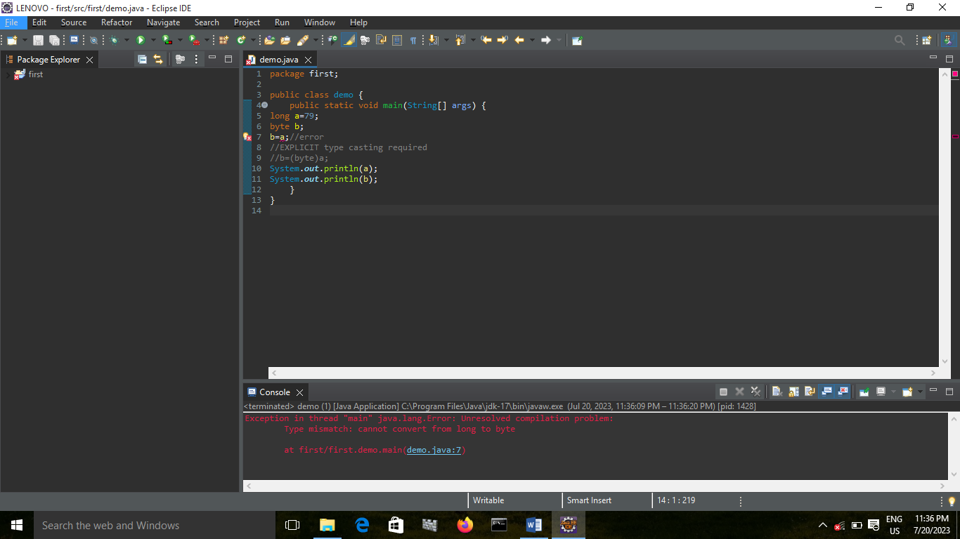

ERROR BECAUSE LONG TO BYTE EXPLICIT TYPECASTING SHOULD BE DONE

LONG TO SHORT:

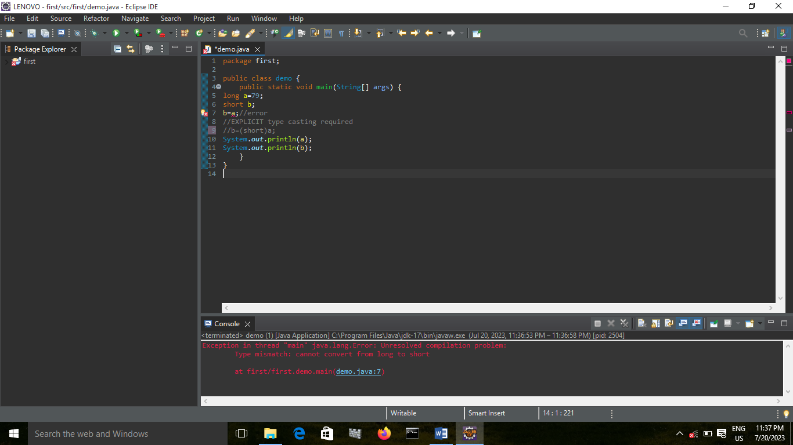

ERROR BECAUSE LONG TO SHORT EXPLICIT TYPECASTING SHOULD BE DONE

LONG TO INT:

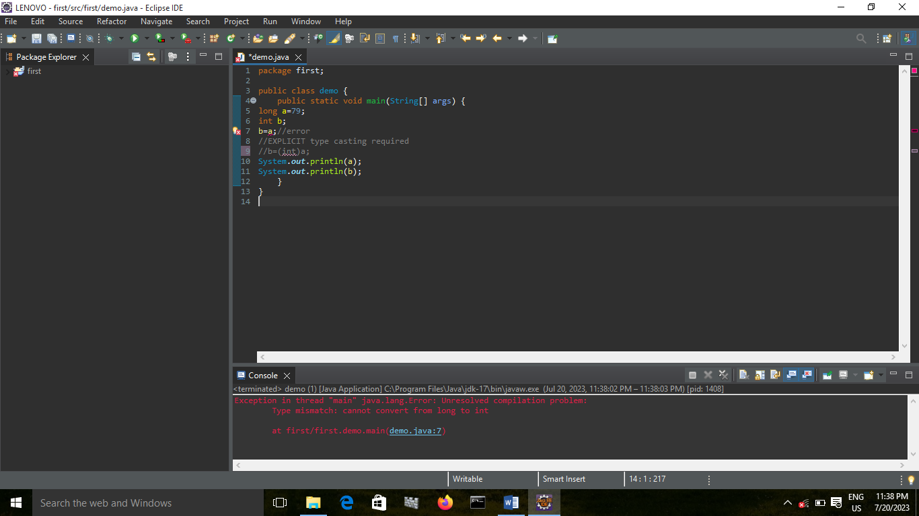

ERROR BECAUSE LONG TO INT EXPLICIT TYPECASTING SHOULD BE DONE

LONG TO LONG:

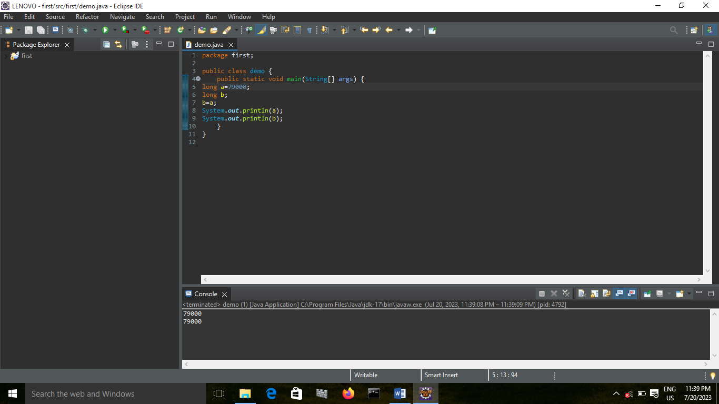

LONG TO FLOAT:

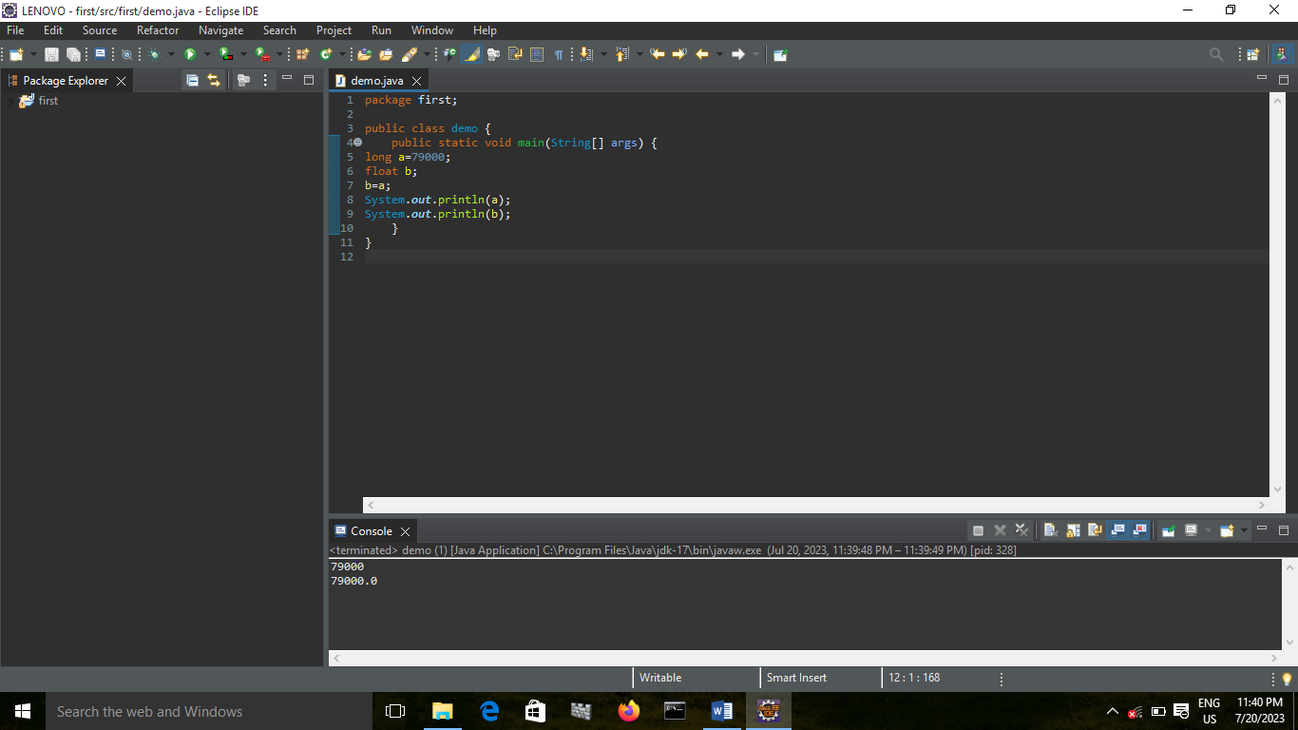

LONG TO DOUBLE:

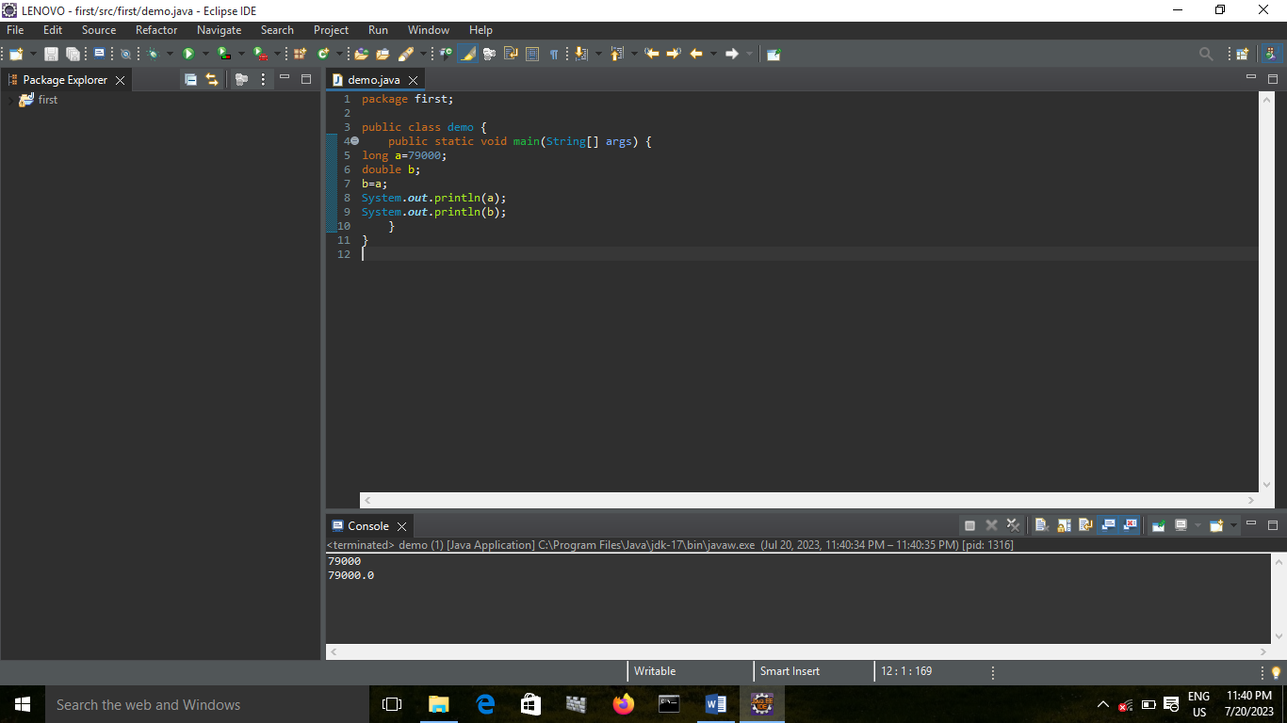

LONG TO CHAR:

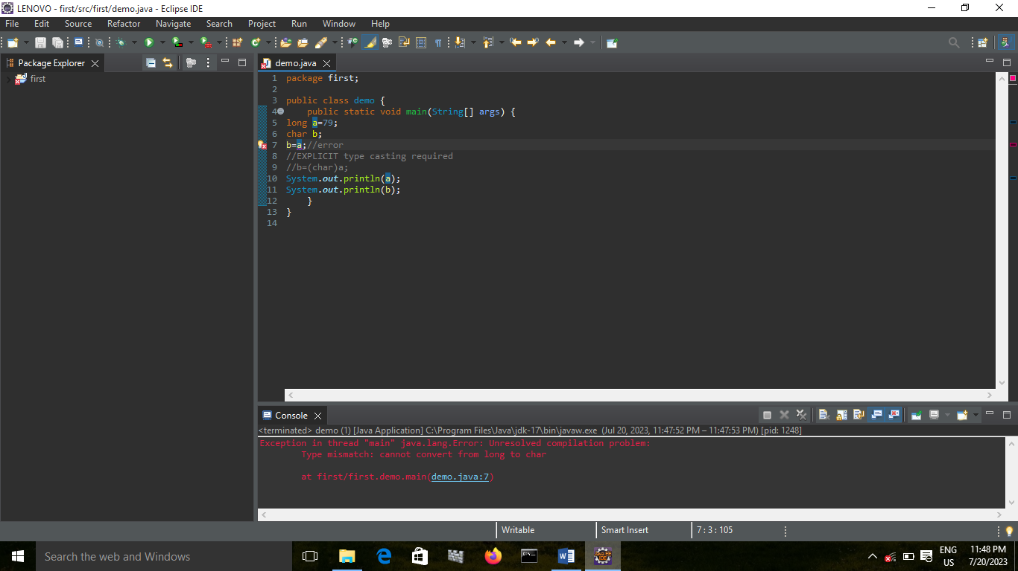

ERROR BECAUSE LONG TO CHAR EXPLICIT TYPECASTING SHOULD BE DONE

LONG TO BOOLEAN:

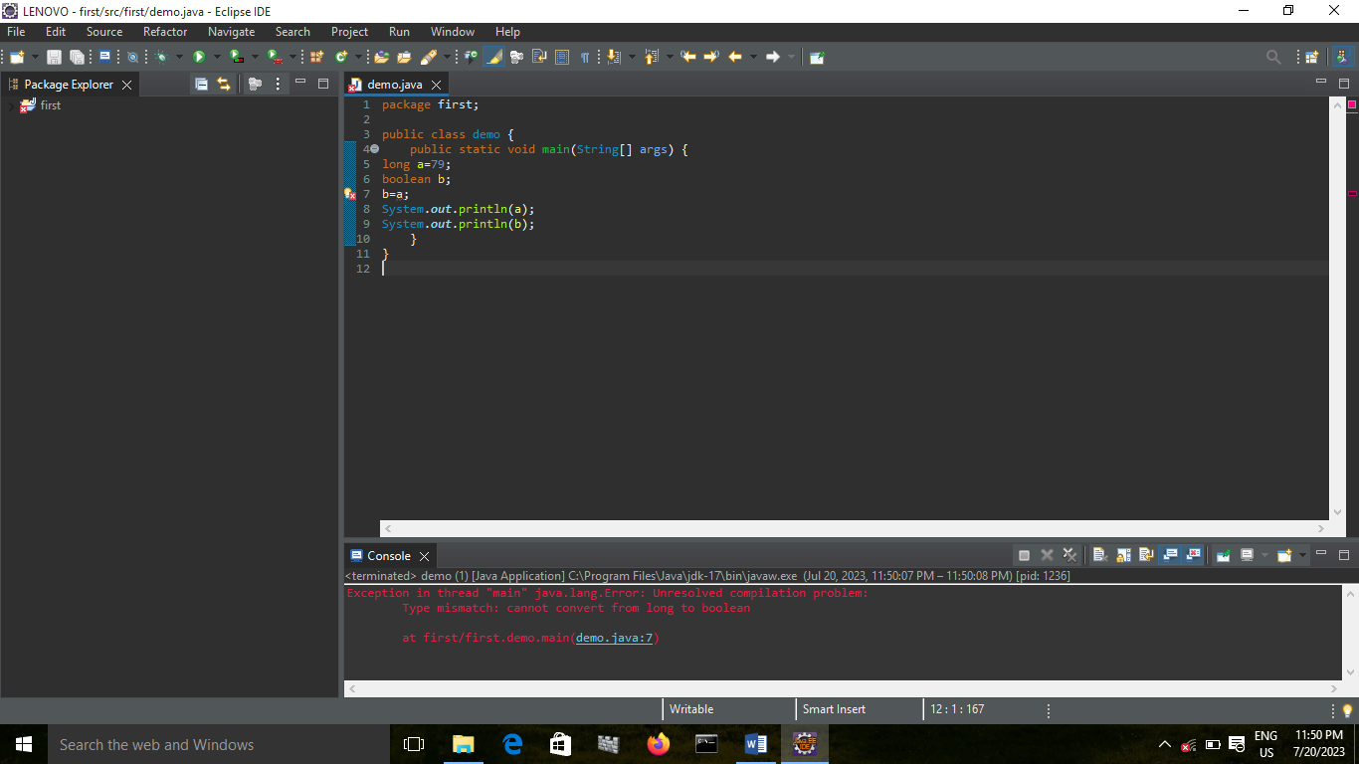

CONCLUSION: NOT POSSIBLE

FLOAT TO BYTE:

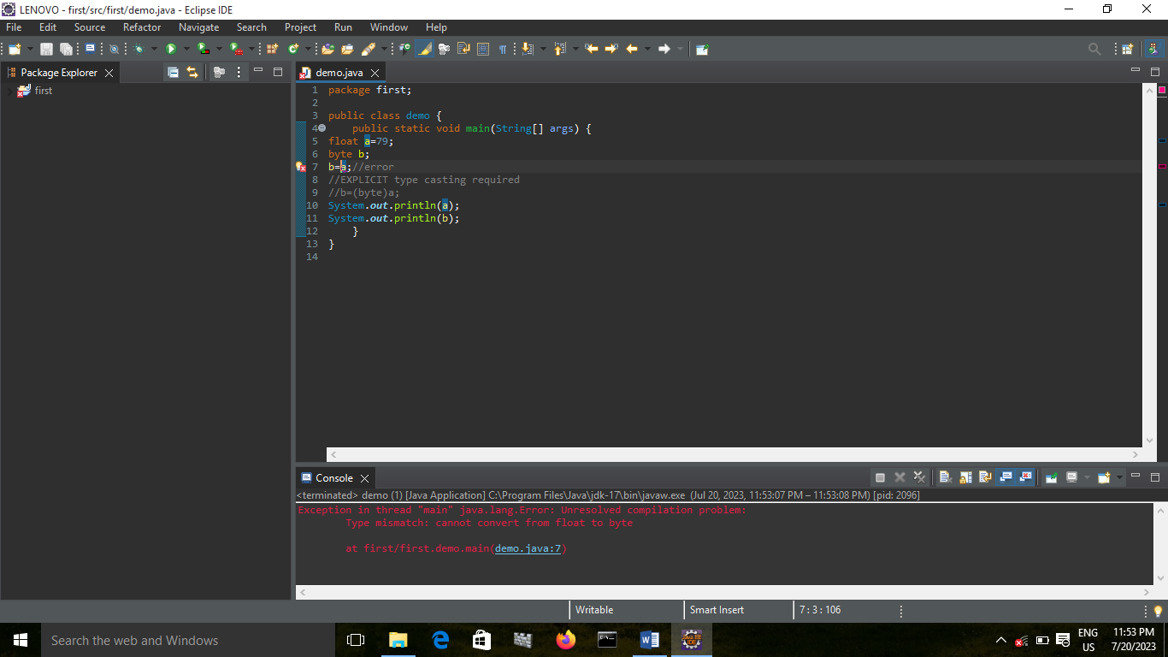

ERROR BECAUSE FLOAT TO BYTE EXPLICIT TYPECASTING SHOULD BE DONE

FLOAT TO SHORT:

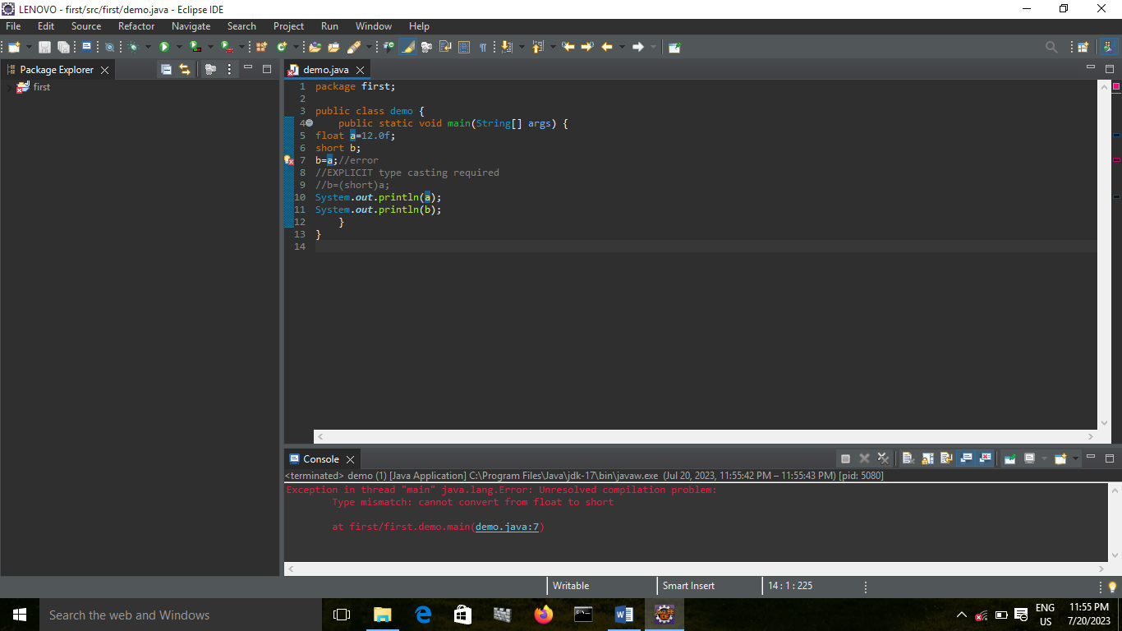

ERROR BECAUSE FLOAT TO SHORT EXPLICIT TYPECASTING SHOULD BE DONE

FLOAT TO INT:

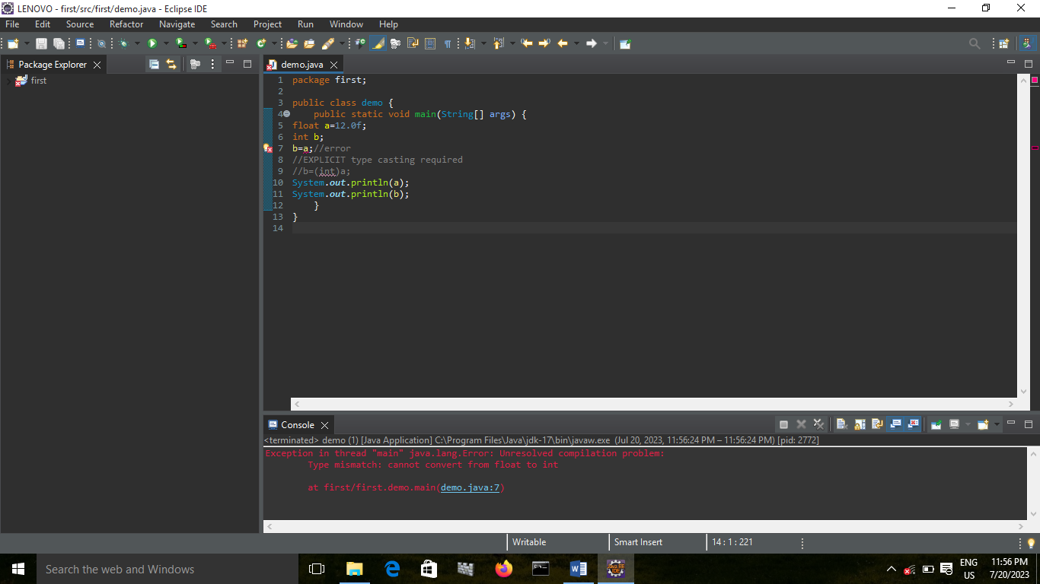

ERROR BECAUSE FLOAT TO INT EXPLICIT TYPECASTING SHOULD BE DONE

FLOAT TO LONG:

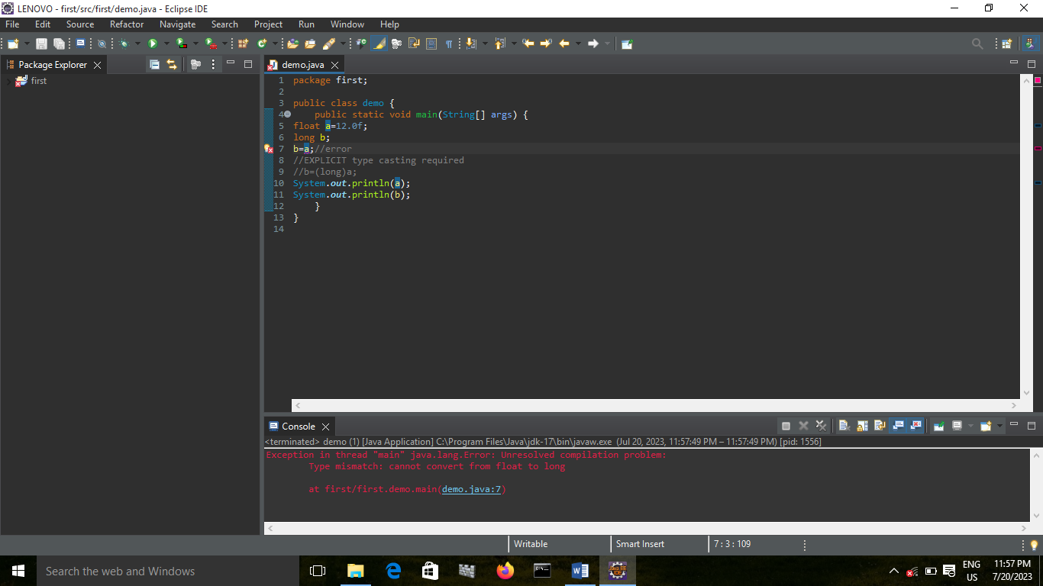

ERROR BECAUSE FLOAT TO LONG EXPLICIT TYPECASTING SHOULD BE DONE

FLOAT TO FLOAT:

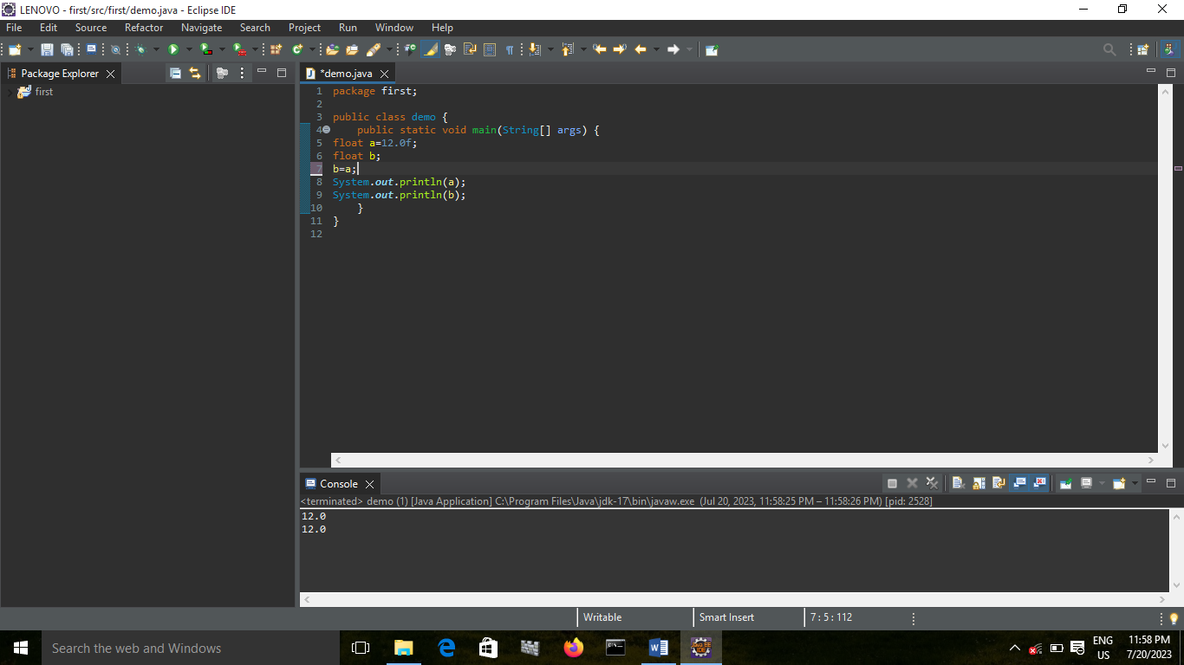

FLOAT TO DOUBLE:

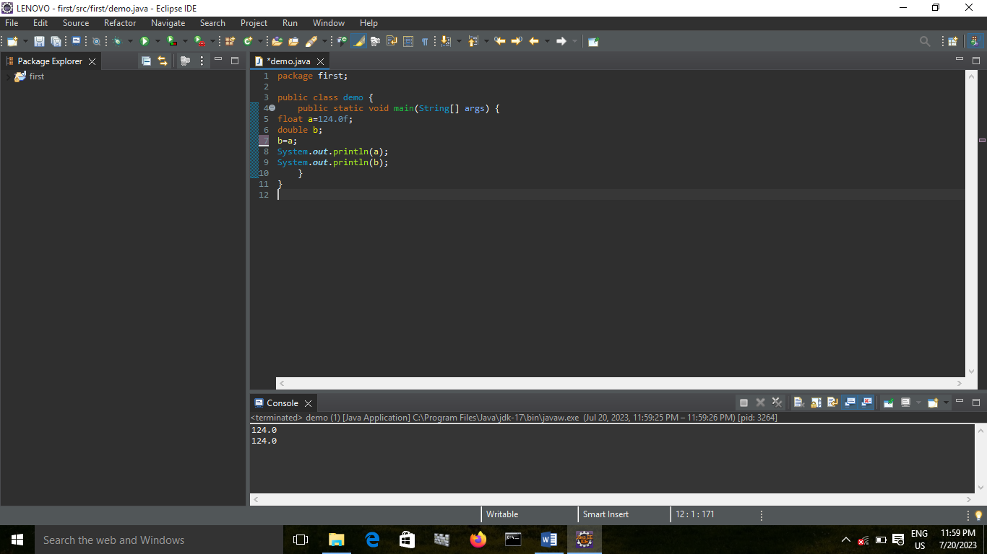

FLOAT TO CHAR:

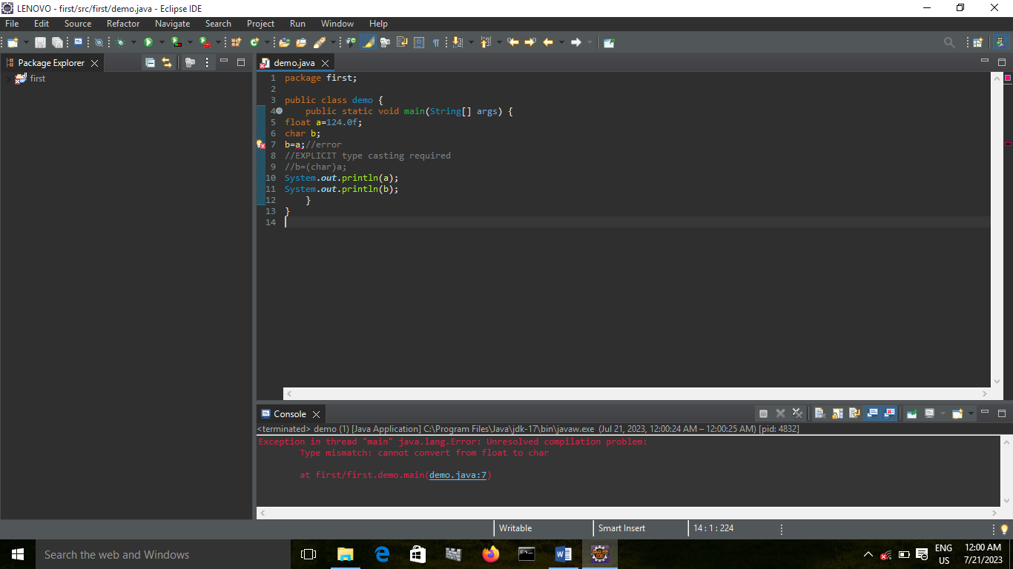 ERROR BECAUSE FLOAT TO CHAR EXPLICIT TYPECASTING SHOULD BE DONE

FLOAT TO BOOLEAN:

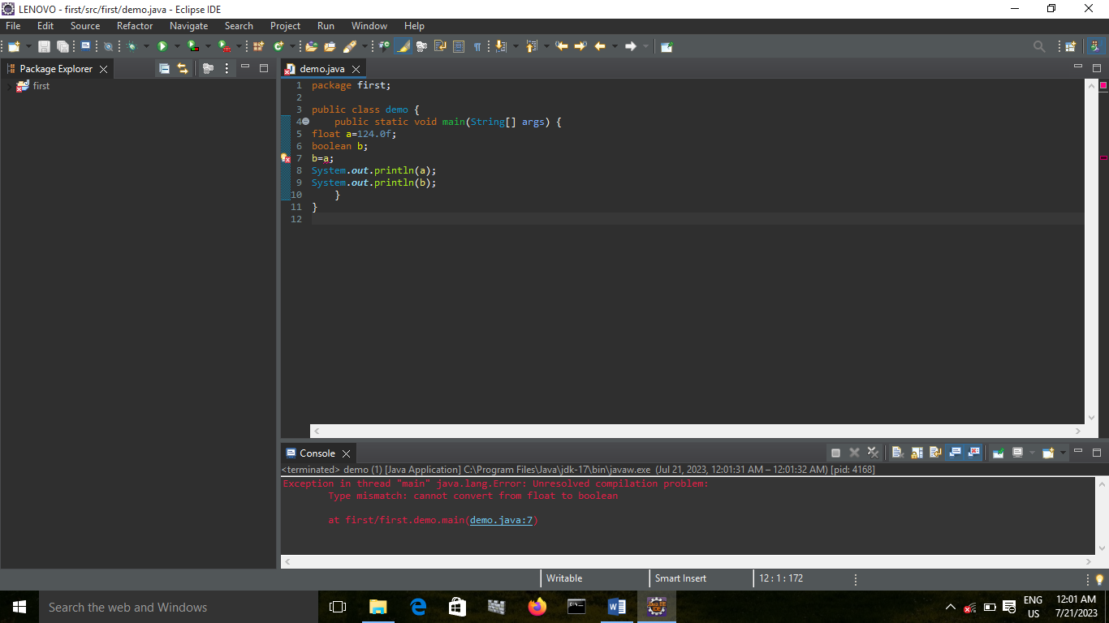

CONCLUSION: NOT POSSIBLE

DOUBLE TO BYTE:

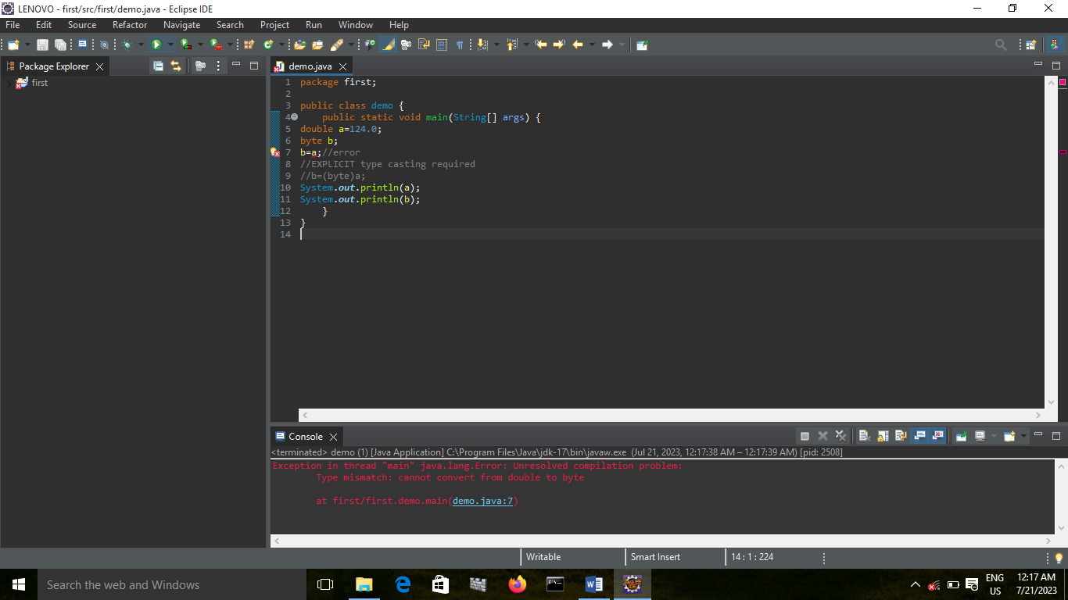

ERROR BECAUSE DOUBLE TO BYTE EXPLICIT TYPECASTING SHOULD BE DONE

DOUBLE TO SHORT:

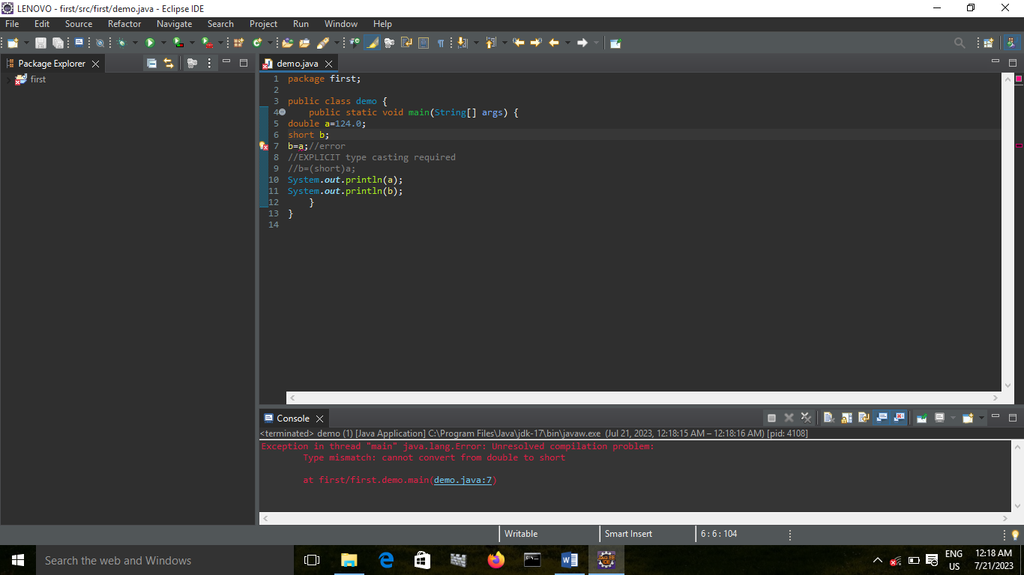

ERROR BECAUSE DOUBLE TO SHORT EXPLICIT TYPECASTING SHOULD BE DONE

DOUBLE TO INT:

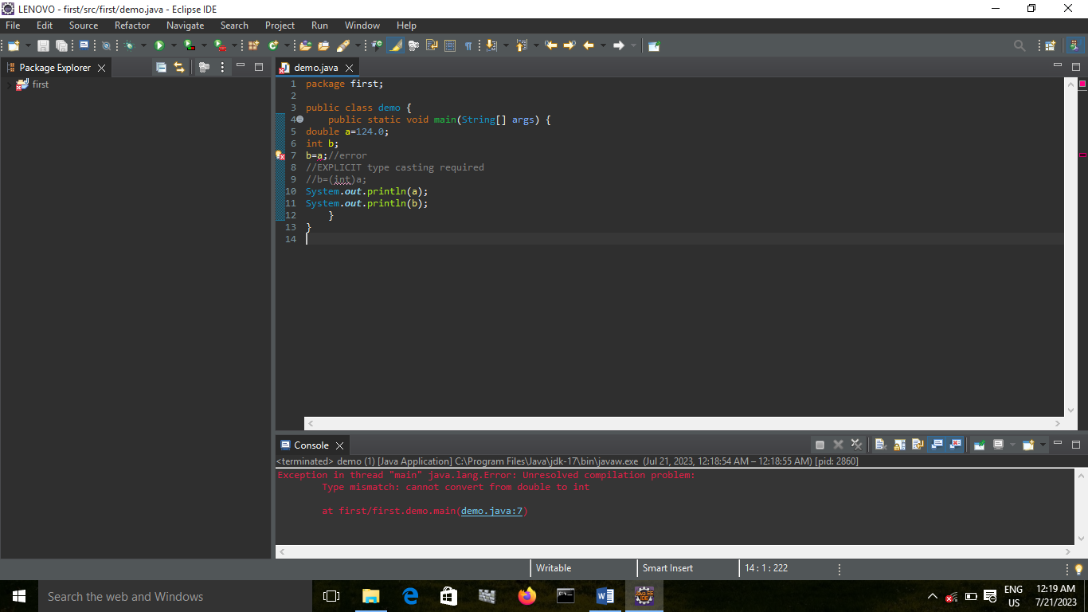

ERROR BECAUSE DOUBLE TO INT EXPLICIT TYPECASTING SHOULD BE DONE

DOUBLE TO LONG:

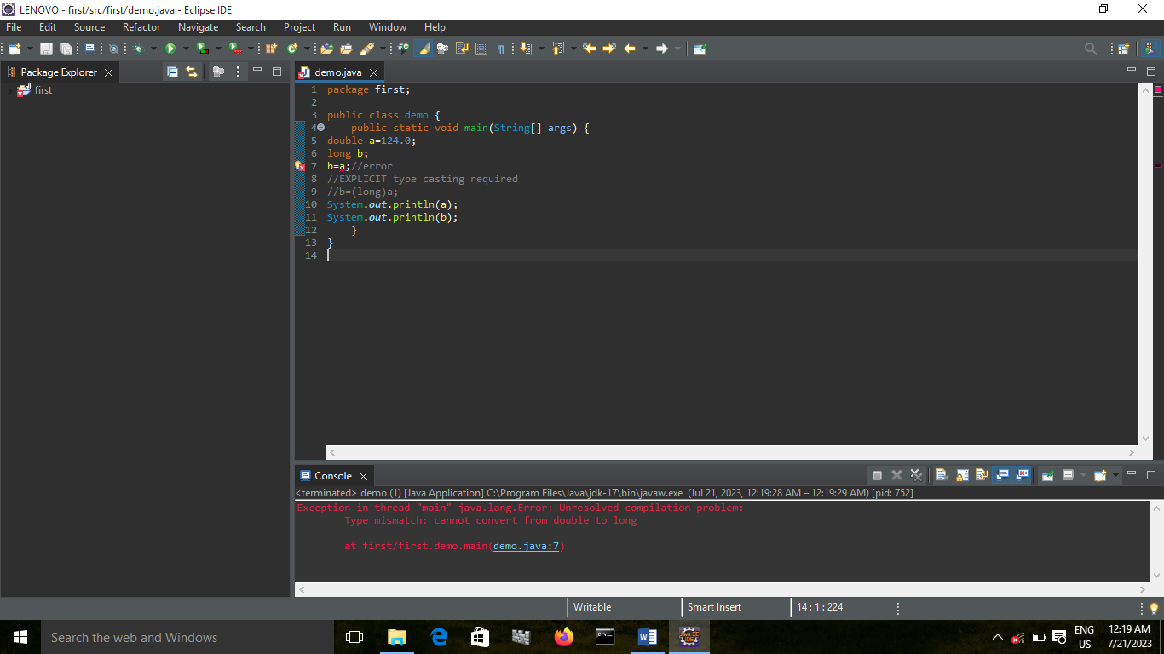

ERROR BECAUSE DOUBLE TO LONG EXPLICIT TYPECASTING SHOULD BE DONE

DOUBLE TO FLOAT:

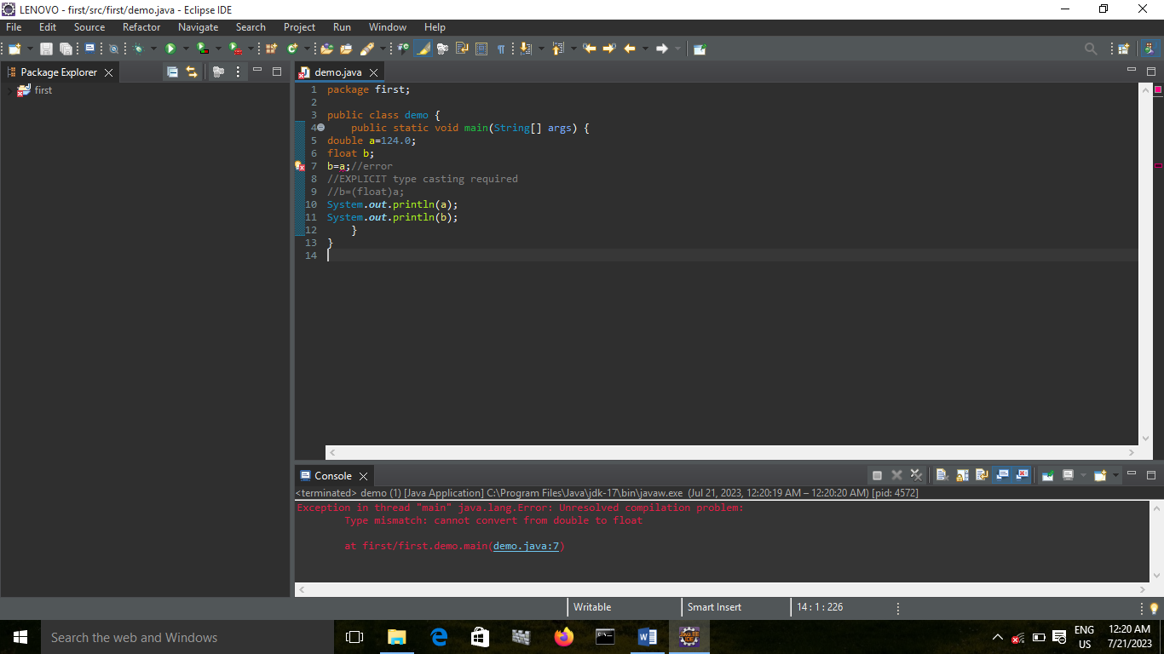

ERROR BECAUSE DOUBLE TO FLOAT EXPLICIT TYPECASTING SHOULD BE DONE

DOUBLE TO DOUBLE:

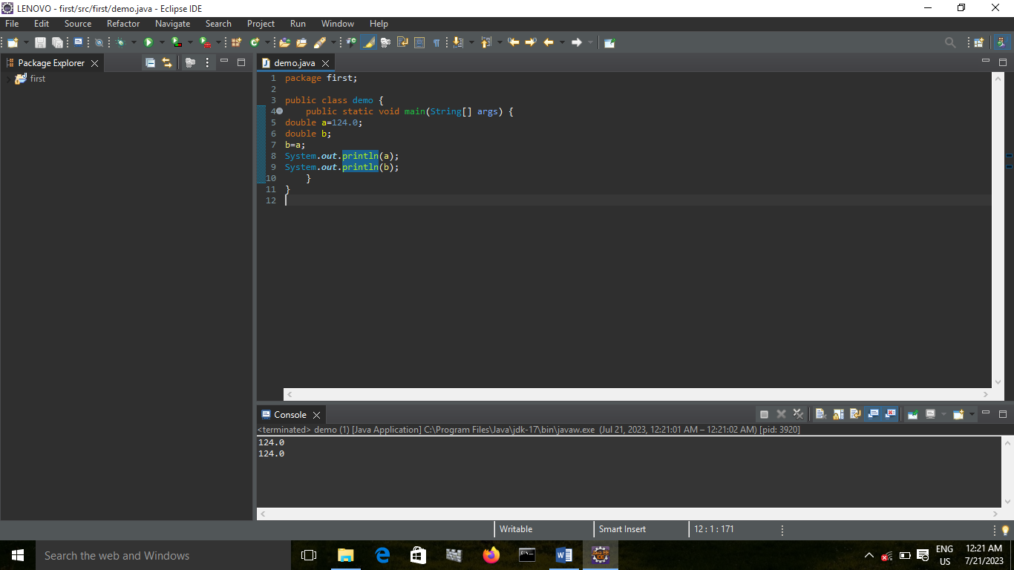

DOUBLE TO CHAR:

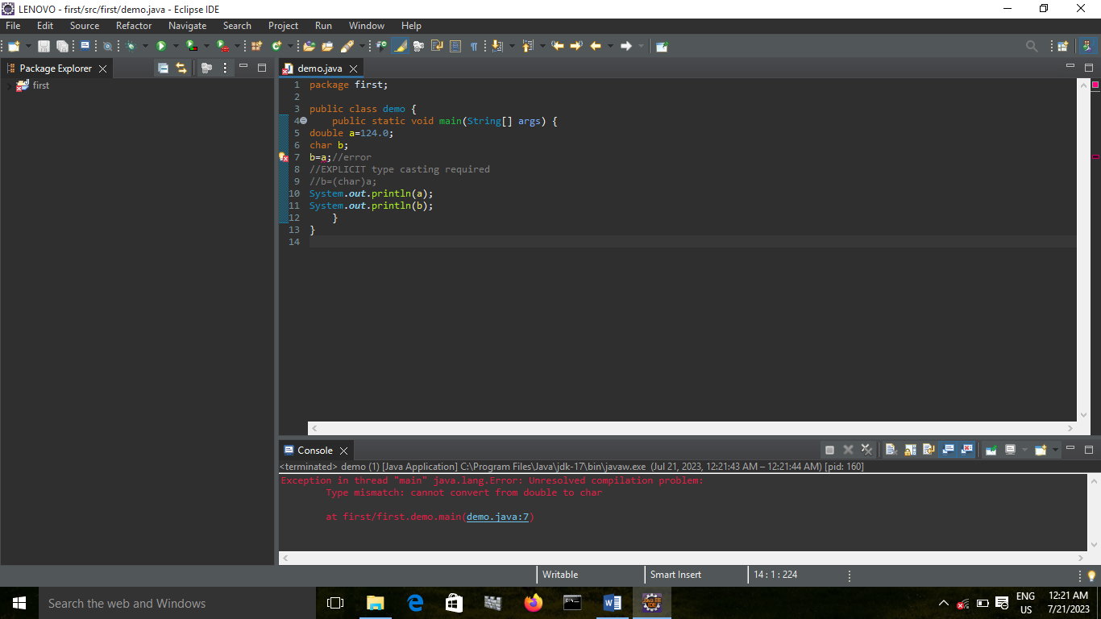

ERROR BECAUSE DOUBLE TO CHAR EXPLICIT TYPECASTING SHOULD BE DONE

DOUBLE TO BOOLEAN:

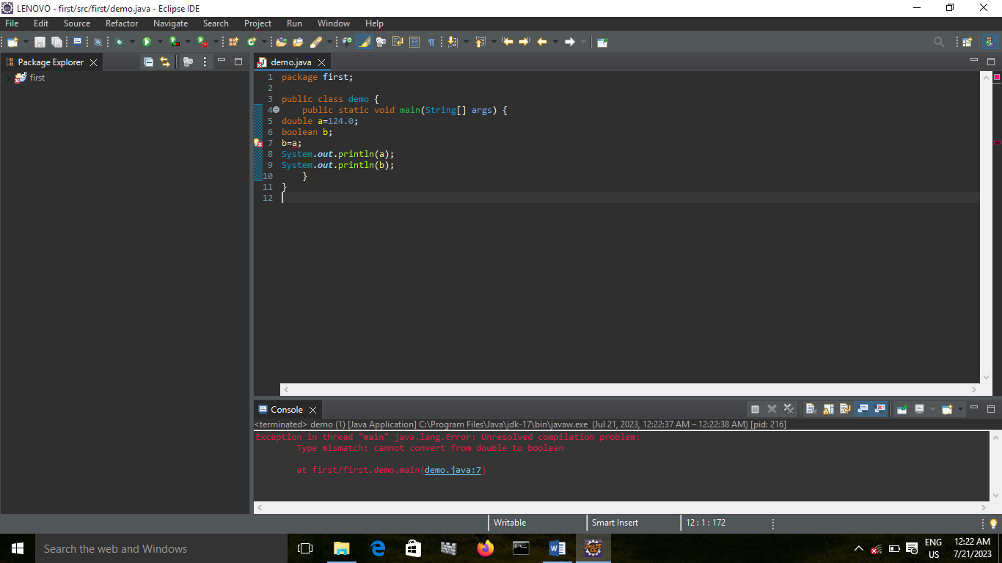

CONCLUSION: NOT POSSIBLE

CHAR TO BYTE:

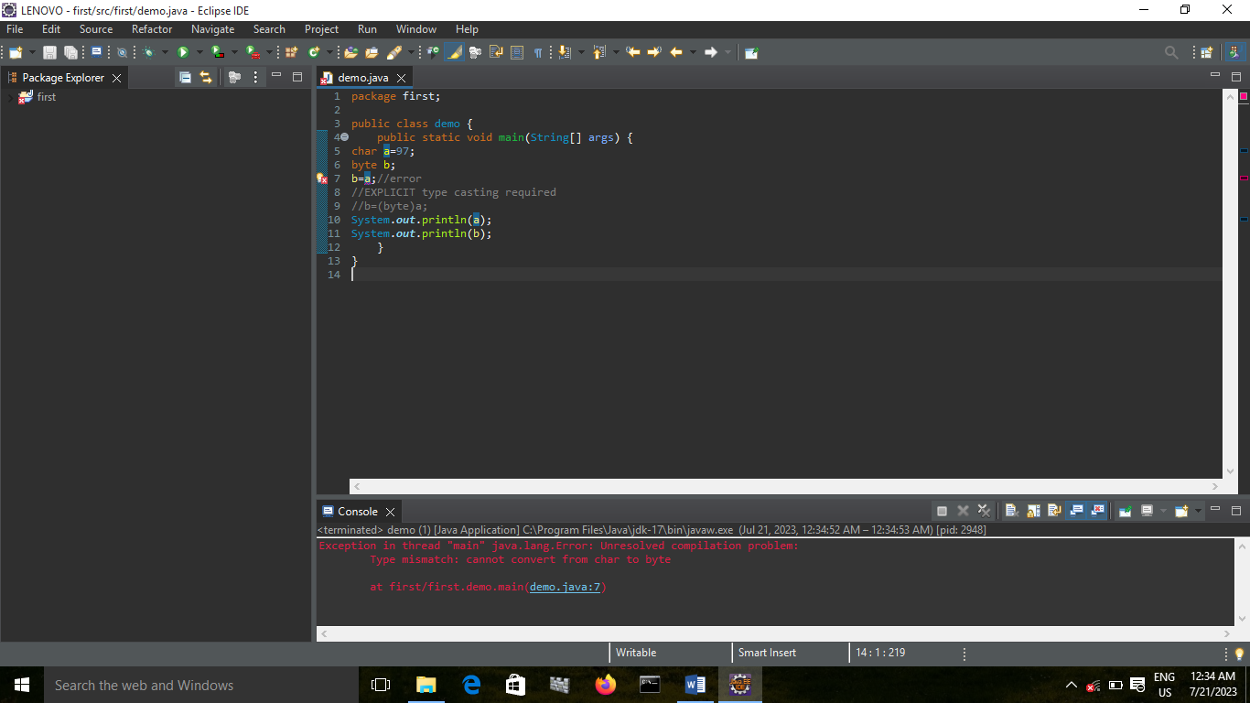

ERROR BECAUSE CHAR TO BYTE EXPLICIT TYPECASTING SHOULD BE DONE

CHAR TO SHORT:

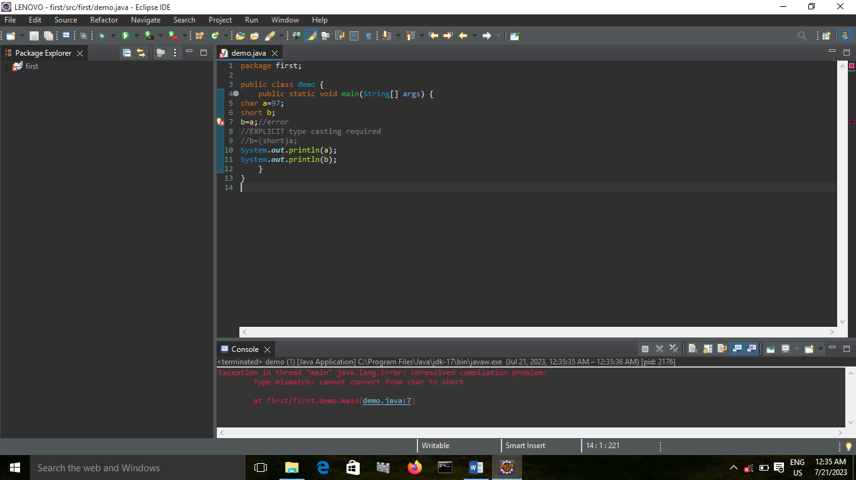

ERROR BECAUSE CHAR TO SHORT EXPLICIT TYPECASTING SHOULD BE DONE

CHAR TO INT:

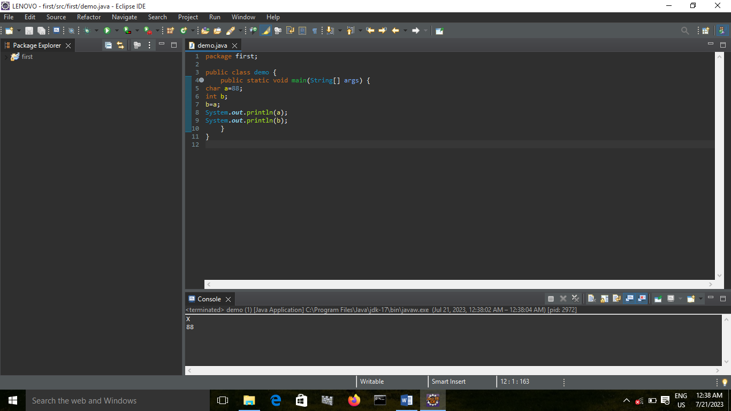

CHAR TO LONG:

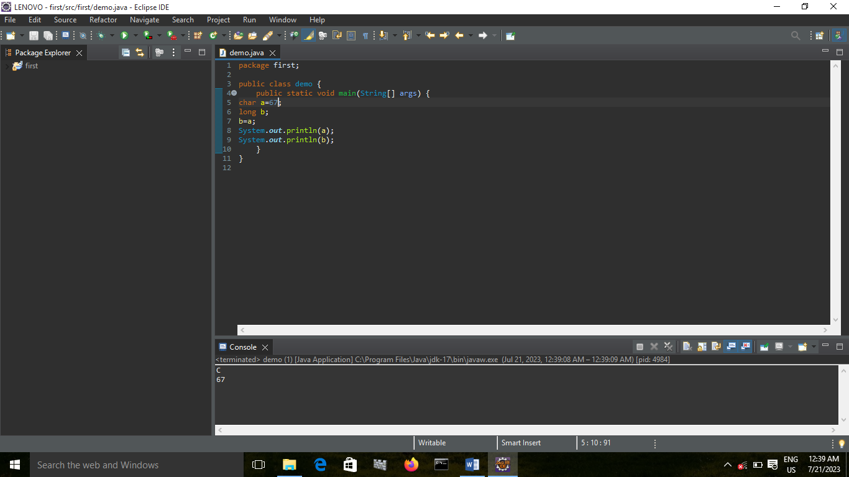

CHAR TO FLOAT:

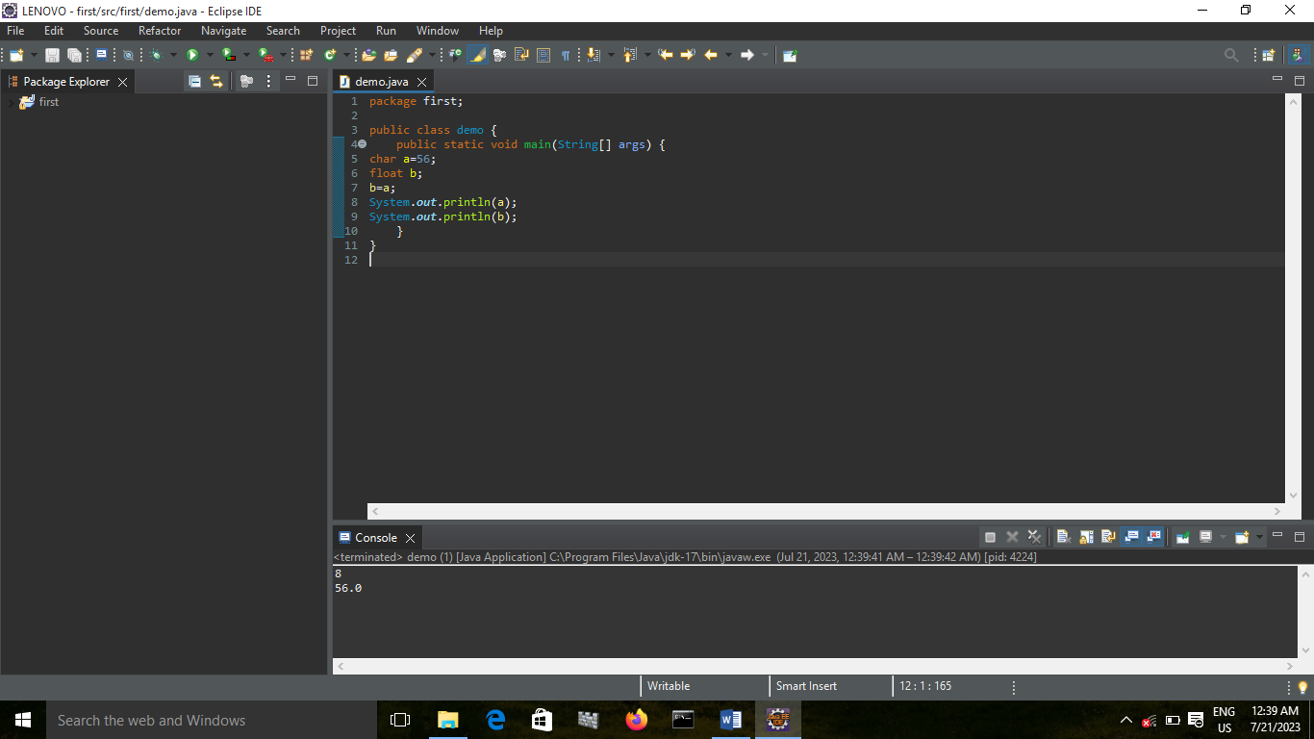

CHAR TO DOUBLE:

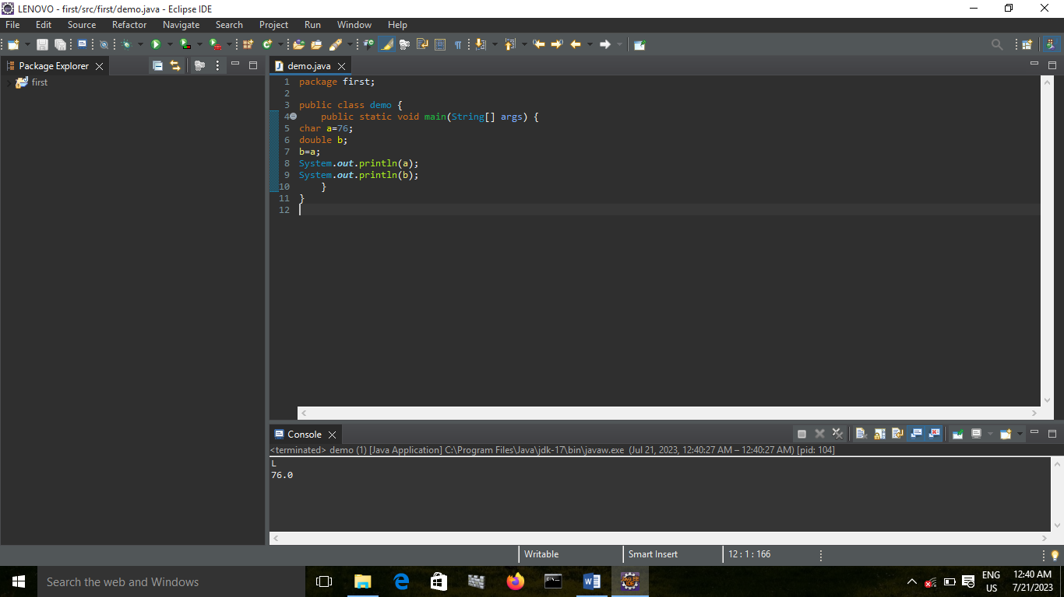

CHAR TO CHAR:

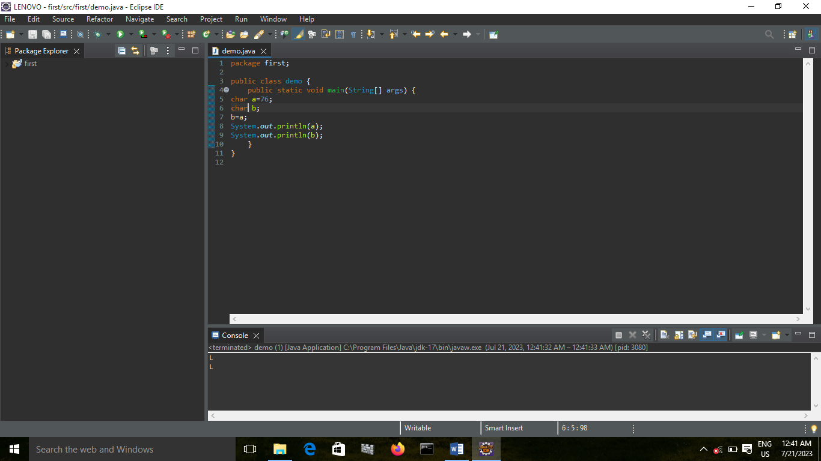

CHAR TO BOOLEAN:

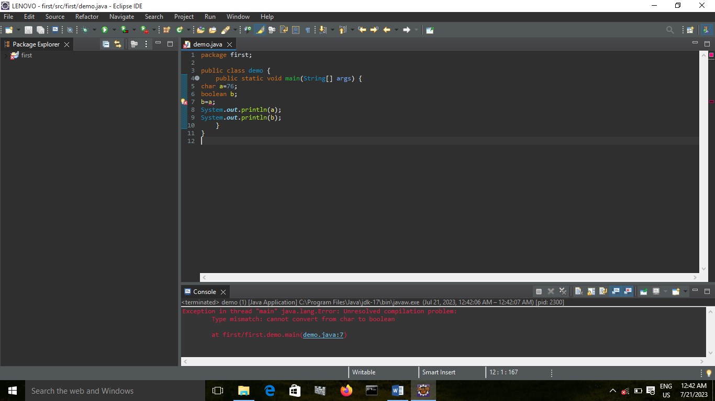

CONCLUSION: NOT POSSIBLE

BOOLEAN TO BYTE:

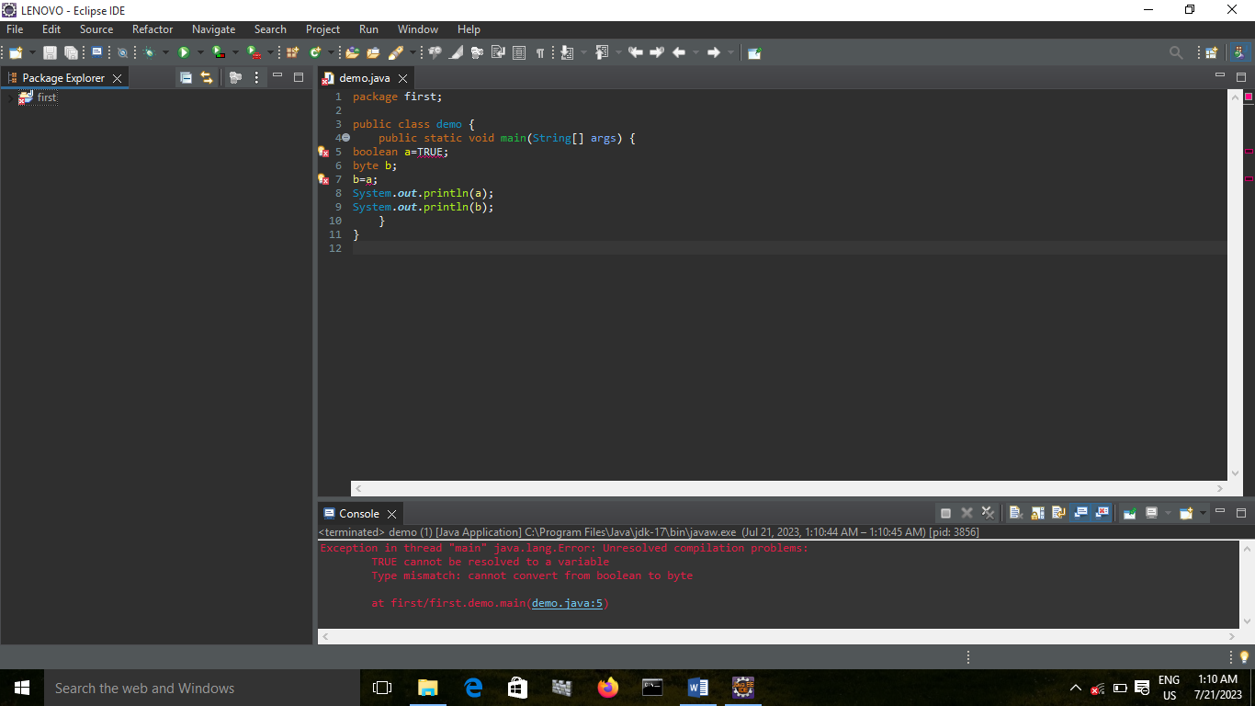

CONCLUSION: NOT POSSIBLE

BOOLEAN TO SHORT:

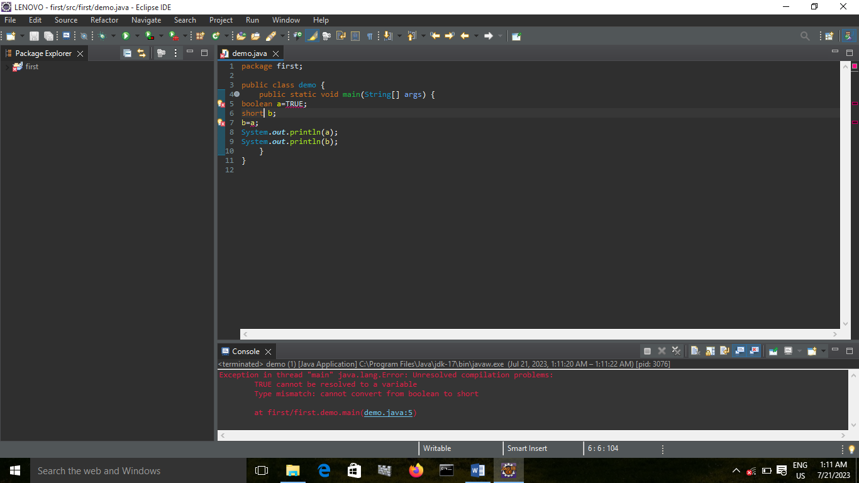 CONCLUSION: NOT POSSIBLE

BOOLEAN TO INT:

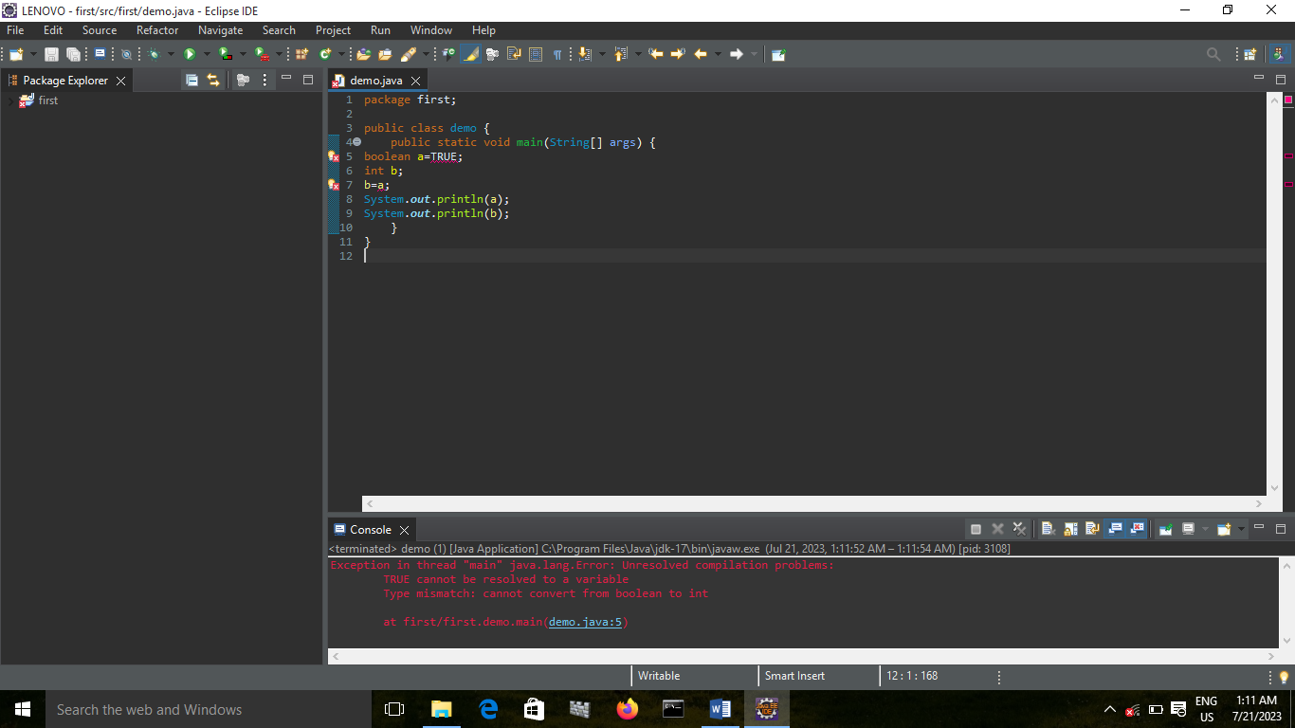 CONCLUSION: NOT POSSIBLE

BOOLEAN TO LONG:

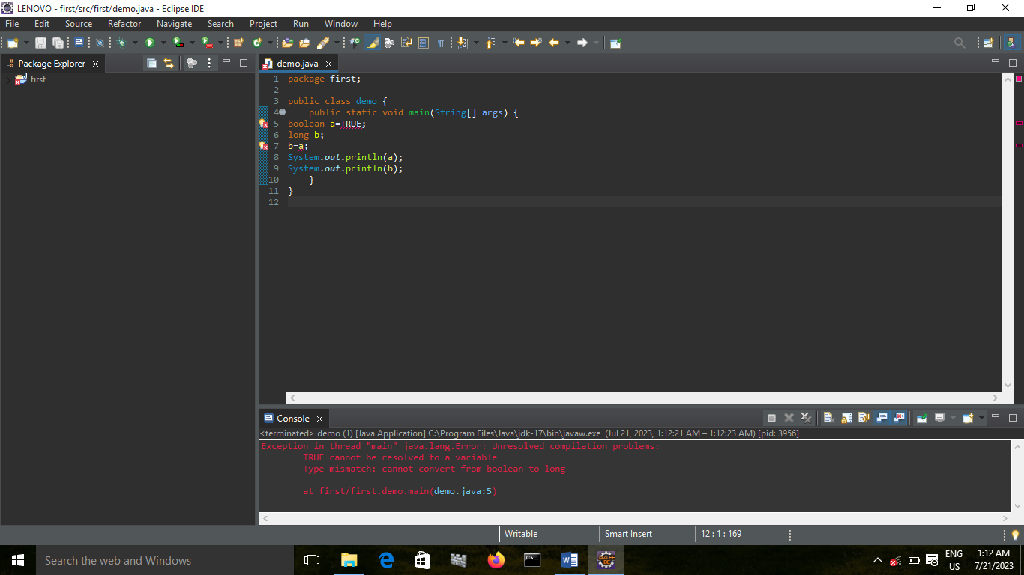

CONCLUSION: NOT POSSIBLE

BOOLEAN TO FLOAT:

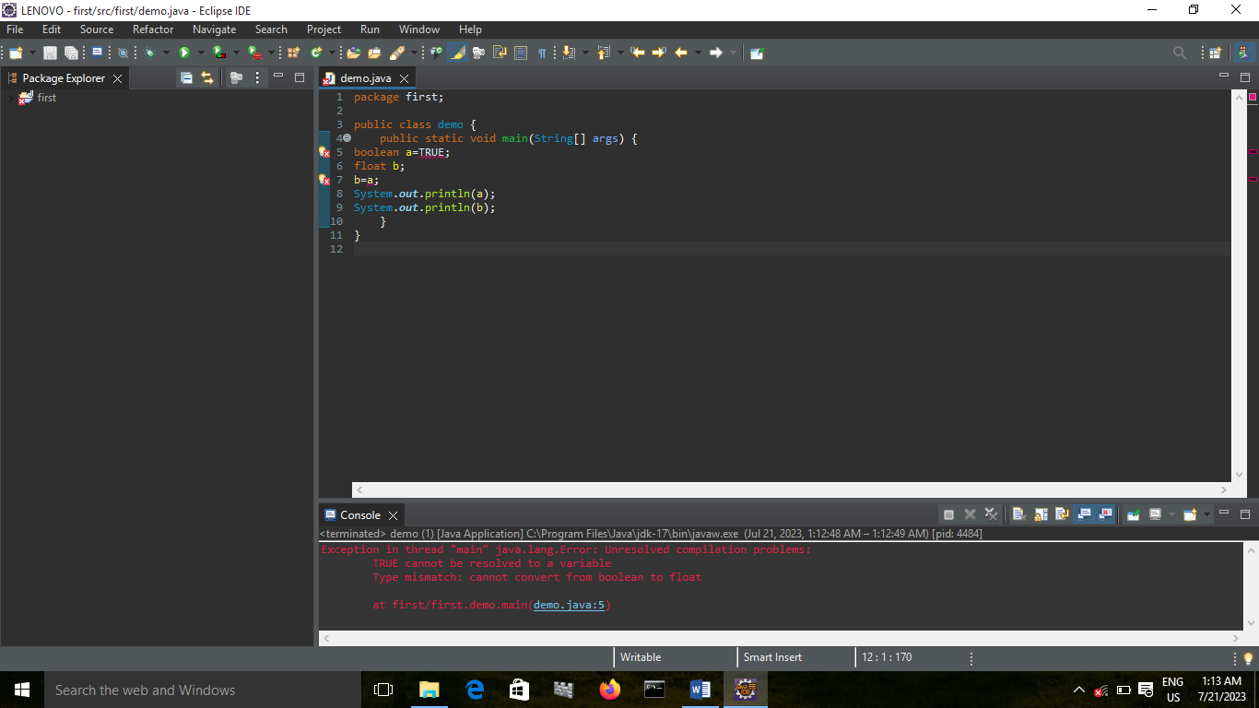

CONCLUSION: NOT POSSIBLE

BOOLEAN TO DOUBLE:

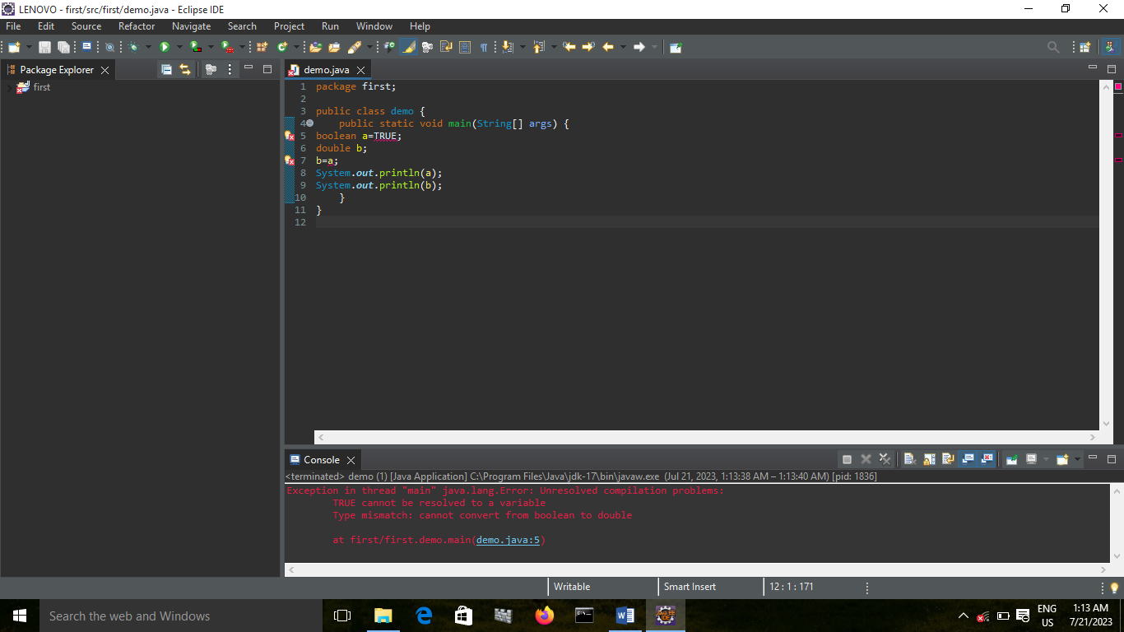

CONCLUSION: NOT POSSIBLE

BOOLEAN TO CHAR:

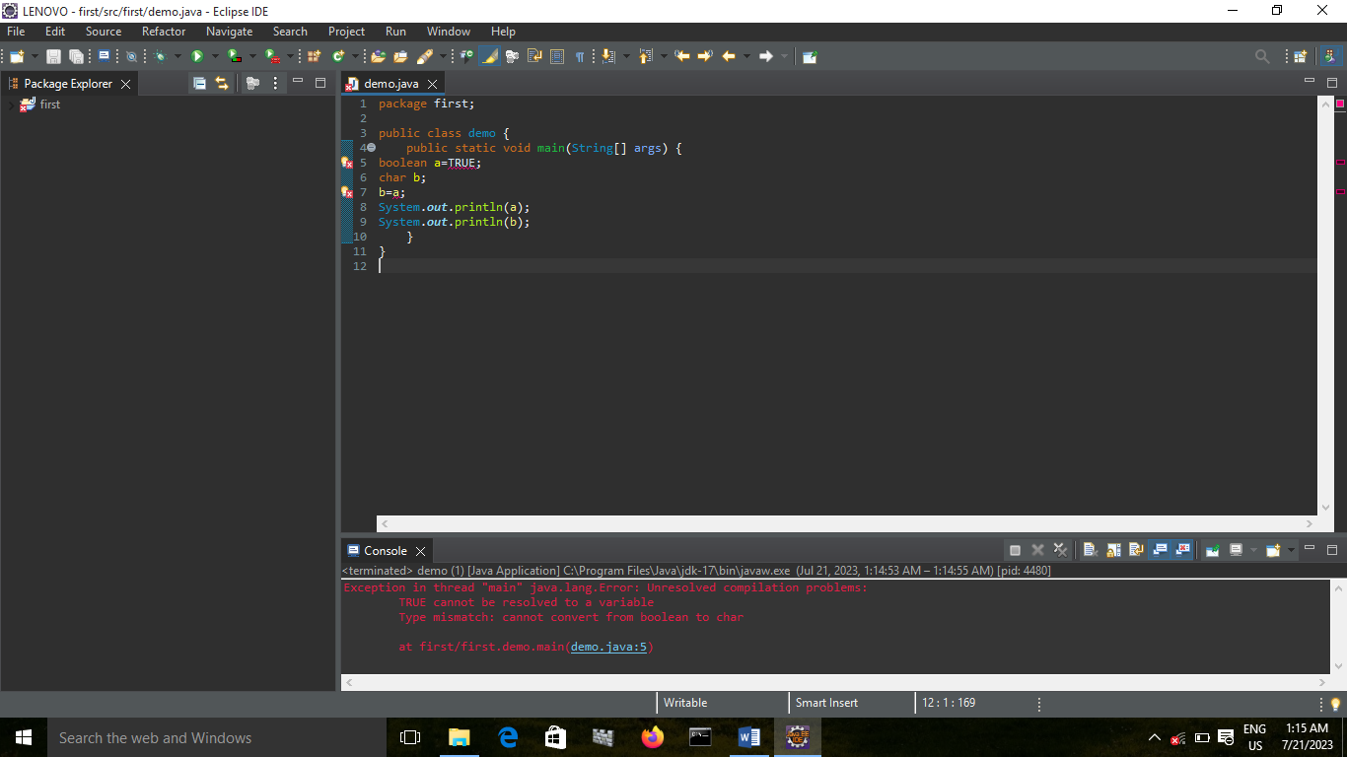

CONCLUSION: NOT POSSIBLE

BOOLEAN TO BOOLEAN:

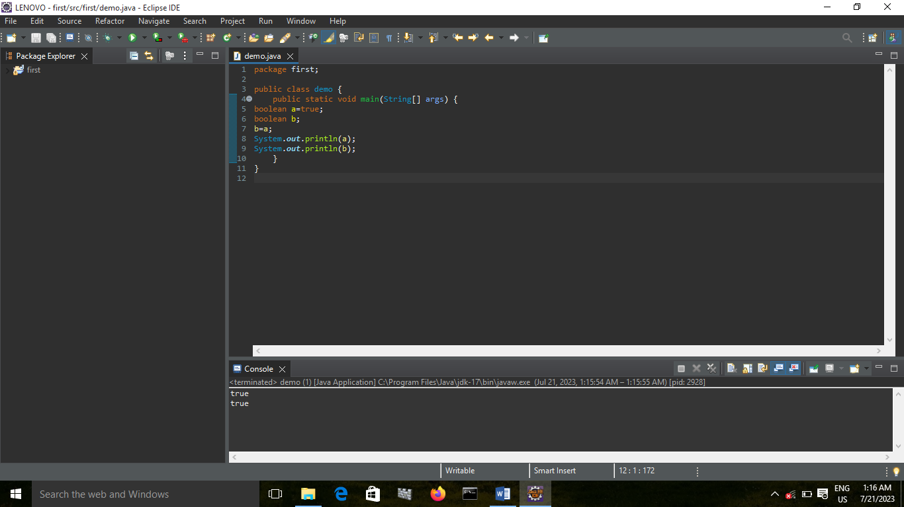

TYPE CASTING TABLE:

|  |  |  |  |  |  |  |  |  |
| --- | --- | --- | --- | --- | --- | --- | --- | --- |
|  | CHAR | BYTE | SHORT | INT | LONG | FLOAT | DOUBLE | BOOLEAN |
| CHAR | NCR | EC | EC | EC | EC | EC | EC | NO |
| BYTE | EC | NCR | EC | EC | EC | EC | EC | NO |
| SHORT | EC | IC | NCR | EC | EC | EC | EC | NO |
| INT | IC | IC | IC | NCR | EC | EC | EC | NO |
| LONG | IC | IC | IC | IC | NCR | EC | EC | NO |
| FLOAT | IC | IC | IC | IC | IC | NCR | EC | NO |
| DOUBLE | IC | IC | IC | IC | IC | IC | NCR | NO |
| BOOLEAN | NO | NO | NO | NO | NO | NO | NO | NCR |